Botswana
Long
Term
Athlete
Developmentnt

ATHLETICS

Relay to Success

A framework to guide Athletics in Botswana
towards lifelong participation and excellence
for all levels: from grassroots to podium and beyond.
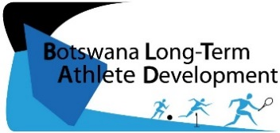
Building Tomorrow Starts Today

Date:2016
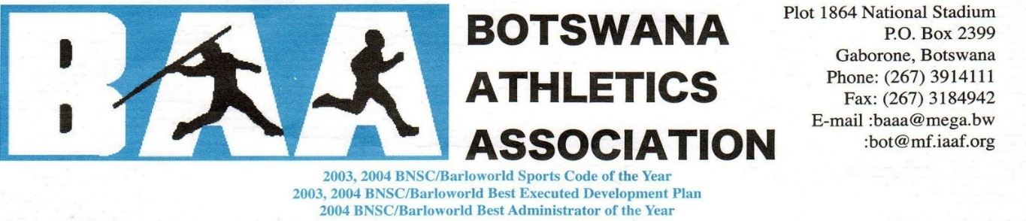

TABLE OF CONTENTS

- BLTAD Athletics Relay to Success: Preface…………………………………… 3
- BLTAD Athletics Relay to Success: Overview………………………………… 5
- Grassroots: Kids Athletics…………………………………………………………. 6
- Youth: Athletics Training………………………………………………………….. 9
- Junior: Elite Experience …………………………………………………………… 12
- Senior: Elite Experience….………………………………………………………… 14
- Running For Life: All Ages ……………………………………………………….. 16
- Appendices………………………..…………………………………………………. 17
Working Group
- Mr. Gable Garenamotse : Sport Development Officer, BAA
- Mr. Mogomotsi Otsetswe : High Performance Coach, BAA
- Mr. Modise Mgadla : Liaison Officer-SD &TS, BNOC
- Ms. Jennifer Brown : BLTAD Consultant

Key Terms
BAA – Botswana Athletics Association
BNSC: Botswana National Sport Commission
BNOC – Botswana National Olympic Committee
BOPSSA – Botswana Primary School Sports Association
BISA – Botswana Integrated Sports Association
BOTESSA – Botswana Tertiarty School Sport Association
CHOPS – Conference Heads of Private Schools
CHIPS – Conference Heads of Independent Schools
ISSSA – Independent Secondary School Sports Association
IAAF – International Association of Athletics Association
Key Stakeholders

Botwana Long Term Athlete Development
ATHLETICS - RELAY TO SUCCESS
Preface
The BAA has enjoyed recent success on the international scene with Olympic 800m Silver medallist, Nijel Amos, and African 400m Record holder, Isaac Makwala, Olympic Youth 200m Silver Medalist Babolki Thebe and 400m Silver Medalist, Karabo Sibanda to name a few.
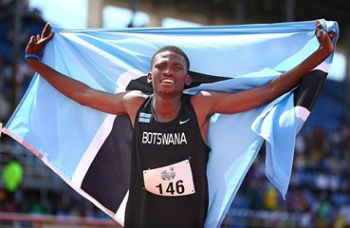
While there are some upcoming stars amongst our youth athletes, the question remains as to what will happen if these few drop out? Will there be a pool of athletes behind them to carry over?
It is for this reason that in 2015, Botswana Athletics Association (BAA) embarked on reviewing its way forward as an Association following the review of BNOC’s Botswana Long Term Athlete Development (BLTAD).
THE BLTAD.
The BLTAD is a framework adopted from the Canadian Sport For Life (CS4L’s) world leading LTAD. It is not a program, but a national strategic framework to guide programs based on scientific and psycho-social principles of growth and development for conducting training programs and competitions for all ages towards long term athletic participation and/or excellence in sport (See Appendix A)
Drawing from the principles of BLTAD, Botswana Athletics’ Association - being the National Governing Body for athletics - reviewed its structured and identified challenges and ways forward through the assistance of a BLTAD consultant from Canada. Several stakeholders were approached including coaches, athletes, and schools. Recommendations were made in the fields of Training Programs, Competition Structures, School Sports, Team Selection, Coach Education, Funding and Policies, and Athlete Support.
Action Plan.
The average age of an Olympic Medallist is 25-30 years?
Yet we often focus winning long before this at junior (U19) or even youth (U17)!
However, studies show that less than 5% of athletes who medal at the U19 world juniors go on to medal at the Olympics. Why??
- Develop to Quickly
- Over train
- Injuries
- Physical Burnout
- Lose Interest
- Mental Burnout
- Limited Support
- Late VS Early Developers
Therefore we must not ignore slow developers and we must carefully foster early talented.(Appendix B)
DID YOU KNOW?
Following this review, an action plan was constructed from the BAA as well as a stage by stage framework, entitled the Relay For Success, which will guide Botswana towards remaining Botswana’s number 1 sporting code that places the country on the world map. However, we must note that,
A Change in Results Requires a Change in Process. In implementing this new strategy, changes will inevitably occur. However, if we wish to have different results we need a different process. “Insanity is expecting change by doing the same thing”
Excellence Takes Time. Research has shown that it takes approximately 10 years to reach the podium. If we are to start in 2016 we will not see results until 2028. Moreover, according to the results from past Olympic, the average age of an Olympic Athletics winner is 28. Given that the complete LTAD begins at around age 8, that full results would not be recognized for 20 years: 2036.
Though the results take long, they would be of better quality than fast tracking results. Therefore we must be patient if we are to produce long-term sustainable results.
Implementation involves the collaboration of all stakeholders. Guided by this framework, the three associated governing bodies, BAA, BNSC, and the BNOC cordially commit to adhering to the action plan with the goal of fostering
More Olympians more often, by system rather than by
chance, and running participation life.

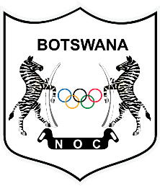
_________________________ _________________________ _________________________
Mr. Moses Bantsi Mr. Solly Reikeletseng Mr Negroes Kgosietsile
President, BAA Chairman, BNSC President, BNOC

BLTAD

RELAY TO SUCCESS
ATHLETICS

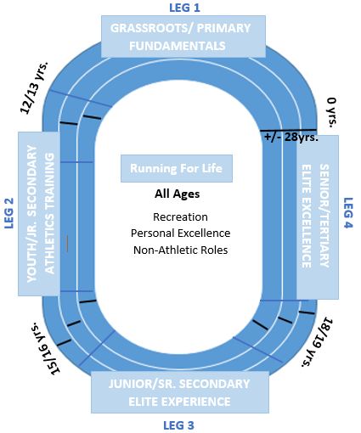
The Athletics BLTAD provides age-appropriate guidelines for training and comeptitions for every age group to guide athletes towards long term participation and/or success from grassroots to poidum and beyond via the Relay to Success.
LEG 1:
GRASSROOTS/ PRIMARY
8-12: Multi-sport games that focus on
FUNdamental Movement & Sport Skills
LEG 2:
YOUTH/JR. SECONDARY
12-15: Athletics specific training, but
multiple disciplines within athletics.
LEG 3:
JUNIOR/SR. SECONDARY
16-18: Formalized training and competition
in a few events with a focus on experience
LEG 4:
SENIOR/TERTIARY
18/19+ High Performance specialized training
and comeptition with a aim of winning.
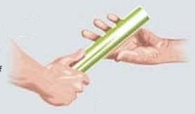
Each Leg is Essential to the Relay.
Getting the baton around the track involves all four legs. Coaches and administrators in every age group contribute to the success at the end. We need to work together at all levels to achieve results at the finish line

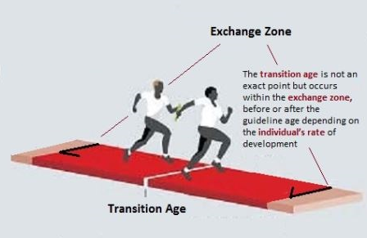
Early Results do not predict the end result.
Athletes develop at different rates. Those who win early in their years, or race, are not always the ones who finish first at the finish line, where it counts.
Slower developers may make up the gaps in a later leg. We cannot over look these athletes.

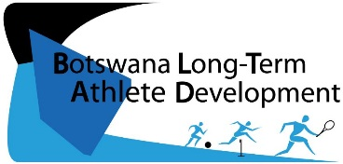
BLTAD: Building Tomorrow Starts Today
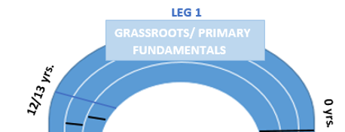
GRASSROOTS: KIDS ATHLETICS
C
Objective: Develop overall FUNdamental Movement Skills (FSS) in an unstructured
environment while developing a love for athletics and sport.
Ages: 6 - 10
School: Lower Primary

Objective: Development overall FUNdamental Sport Skills (FSS) through
multi-sport games in more structured environment
Ages: 10 – 12/13
School: Upper Primary

This is the first leg of the relay to success and is a critical component to future results. The goal is not necessarily to win, but to build a base for future athletics success through FUNdamental Movement and Sport Skills in all sports, and all events. This will allow them to participate in a wide range of physical activity and sports that will also contribute to their holistic development as an athlete. The goal is also to have fun and enjoy sport: no matter how talented the child, if they do not enjoy the sport, they are not likely to continue.
OVERVIEW

Types of Training: Short, Simple, Fun Games
Skills to Train: FUNdamental Movement, Athletics, and Multi-sport Skils, Rules
Types of Competition: Modified events focusing on Skill Development
Number of Sports: 3-4
Duration of Training: 30 – 60 min
Frequency per Week: 2-3 sessions
Frequency of Other Sports per Week: 2-3 sessions
Duration Per Year: At this age, athletics generally happens through school systems in Term 1 for government schools and Term 2 for non-government schools. Ideally, athletics should take place for at least two term’s of the year.
Key Stakeholders/Programs: BOPSSA, CHOPS, CHIPS, Pre-schools, Re Ha Ba Bona Ha, Kids Athletics
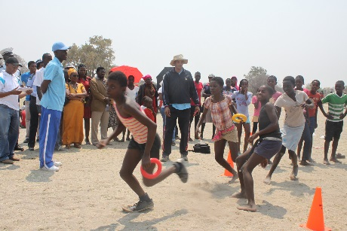
The IAAF’s Kids Athletics is the Ideal system to be used for children under the age of 12. It is based on games using modified equipment and rules and focuses on the development of all movement skills through mixed gendered team competitions.

- FUNdamental Movement Skills (FMS) At ages 6-10, athletes should learn the ABC’s of FUNdamental Movement Skills: Agility, Balance, and Coordination (See Table 1, Appendix C)
This is the golden age of learning. A childs brain is developping rapidly and are able to learn motor skills, coordination, agility and speed.

However, their physical development is slow and they do not have the capacity to develop long speed, endurance, or strength and conditioning.Therefore the focus of this stage should be the following:

PHYSICAL
GRASSROOTS TRAINING CONSIDERATIONS

- FUNdamental Athletic Skills (FAS) At ages 10-12, rather than focusing on athletics specific events (i.e., 100m, Long Jump, Shot Put), athletes should be learning the FUNdamental Sport Skills of Running, Jumping, Throwing and Wheeling (See Table 2, Appendix C) through fun games.

- FUNdamental Sport Skills (FSS) Athletes should also learn FSS of multiple sports. This can be incorporated in athletics training (i.e., football for warm-up or a cross-training day). Or allow them time to participate in other sports by limiting athletics to 3-4 times a week and do other sports the other days. See Table 3, Appendix C for transferable.

- Fitness: Flexibility and Short Speed. Deliberate strength and conditioning is not needed at this age. This can be done as a by-product of the games and activies. I.e., jumping and sprinting is a form of body-weught strength & power training at this age.
TEACHING & PSYCHO-SOCIAL CONSIDERATIONS

Kids are Sensitive | Build self-confidence through positive encouragement and feedback.  Structure activities for success: i.e., multiple winners, focus on small goals, and provide activites not too far out of the athletes abilities
Kids are Restless | Limit explanations and maximize participation: Keep It Simple Silly (KISS).  Keep kids interest by playing fun games rather than formalized training.
Kids are Imaginative | Let them explore movements and invent games/rules through both structured  (guided) and unstructured (unguided or free play) enviornaments.  Even let them create their own modified equipment (i.e., kids athletics).
Diversity and Inclusiveness are Key | Kids need to learn a range of movements over a variety of terrains in a multiple sports in both structured and unstructed environments. Play should also be inclusive to children of all abilities and backgrounds through mass participation.
Parents Play a Role | Kids are dependent on their parents. Parents may push their to achieve early results unaware of the stageobjective or long term goals. They should be informed perhaps via a beginning or term or season meeting.

Winning is not important at this stage; before a child can win, they must be given a chance to learn and develop. Pressure to achieve quick results will rush development, forcing athletes to develop few specialized skills that allow them to win early but limited hollistic develop that will help them win later: when it counts.
Development appropriate:
- Shorter distances,
- Lighter implements
- Lower hurdles
- Modified implements
(softball throw vs javelin)
- Modified rules
- Enter in multiple events (a run, jump, and throw)
- Mass Participation
(VS Elimination)
- Games (i.e., Kids Athletics)

GRASSROOTS COMPETITION
“Sacrifice the primary medal for an
Olympic medal”
Note: Competition is OK; it’s definition should just be developpmentally appropriate by modifying events.

Team Selection:
Teams are generally selected at the beginning of the season without giving them a chance to develop. Like a test, students should be given time to learn, or develop, before writing an exam, or put on trial/competition. Moreover, athletes grow and learn at different rates and some athletes are better simply because they grew faster than others. (De)selecting too early may turn away potentially talented athletes.
- Avoid Team Selection and focus on mass particiation
- Select Tiered teasm (A,B,C)
- Delay Team Selection until the last oppourtunity before competion
- Re-asses selection over time

‘Coach Recogntion:
Coaches should be recognized for their development efforts. Recognizing, awarding, or funding grassroots coaches based on the results they achieve will send in-consistent message to promote development while awarded for reuslts
Kids Athletic Report Cards (KARC):
To help guide the coach to develop FUNdamental Athletics Skills and provides another form of progress
to paresnts besides only reults.
See Appendix D
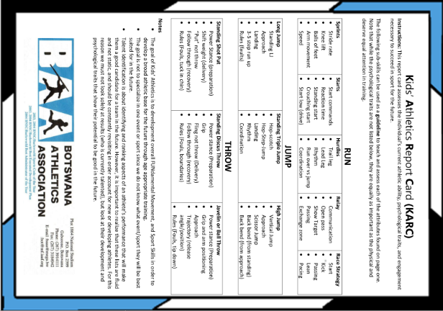
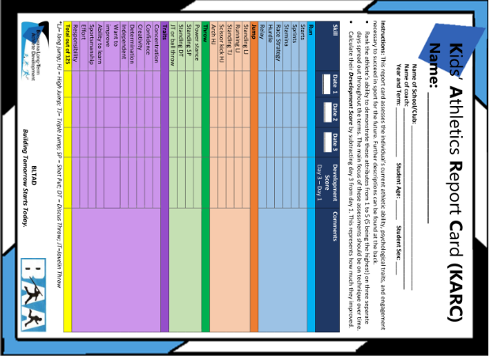

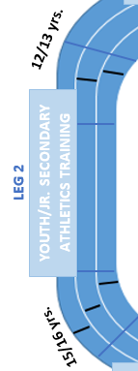

Sub-Youth: Athletics Training

Ages: 13 - 15
School: Jr. Secondary
Objective: Intro to athletics specific training while
in multiple events and sports

This is the second leg of the relay to success and is introductory stage to athletics training. Athletes have learned their FUNdamentals and participated in modified competition for fun. They are now ready to start athletics training and competition. Howevr, it should be noted that this is not ELITE training or competition but an INTRO to training and competition. Advancing into elite oriented competition too soon may cause injuries and burnout. Progressive transition is needed for sustainable long-term results.
OVERVIEW

Types of Training: Introduction to athletics training with formalized warm-up, training
session, and cool down.
Skills to Train: Athletics specific skills in multiple event disciplines along with strength, endurance and long speed training, intro to mental skills.
Types of Competition: Introduction competition with a learning focus
Number of Sports: 2-3
Duration of Training: 60 – 90 min
Frequency per Week: 3-5 sessions
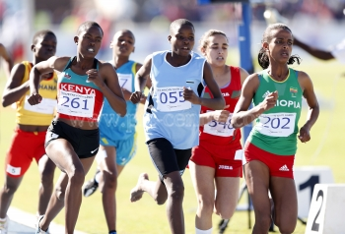
Frequency of Other Sports per Week: 2-3 sessions
Duration Per Year: At this age, athletics generally
happens through school systems in Term 1 in both
government and non-government schools. Ideally,
athletics should take place throughout the year.
Key Stakeholders: BAA, BNSC, BISA, ISSSA

YOUTH TRAINING CONSIDERATIONS

1) Overload
2) FITT (Frequency, intensity, type, time)
3) Progression
4) Specificity
5) Reversibility
6) Rest-Effort balance
7) Variety
7 PRINCIPLES OF TRAINING
PHYSICAL

- Introduction to formalized athletics training incorporating training
sessinos of warm-up, main session and the 7 key factors of training

- Introduction to deliberate physical fitness training with a focus
on developping long speed, power, and endurance as well as
body weight strength.

- Rather than focusing on FAS such as running, jumping, throwing,
athletes are now training event specific: 100m, 800m, long jump,
shot put etc., while focuing on 2 or 3 events from multiple
disciplines (i.e., run and field)
- Multiple sports are still encouraged to avoid burnout and for
transferable skills. A minimum of 2-3 are recommended. These
sports could be used as cross training (i.e., football for tempo/
endurance days)

PYSCHO-SOCIAL

- Introduction to mental skills training such as imagery, self talk, goal setting, focusing

- Health eating and recovery tactics should emphasised whle cautioning disordered eating especially considering the peer-pressure directed towards looks for the female adolcent athlete. Athletes should understand that food is fuel for their body, not enemy. They should think of eating food to fuel their body to train rather than training to burn fuel to loose weight and eat: eat to run or run to eat?’

CAUTION: This age has the highest rate of drop out.
Adolescents may be focusing on academics, have new interests and may be pressured by their peers to try new activities. Rather than denying them this oppourtunity, let them try other activities giving them days off and encouraging a balanced lifestyle.
If not, they will think they are forced to go to athletics and that athletics is stopping them from trying other things so they may rebel against it and quit. Besides, having days off is recommended at this age as a refresher do they do not burnout or lose interest.

Like the grassroots winning is still not the main focus at this stage; the focus of this stage is to learn from competition. Competition should also have modified events to suit IAAF development measures with shorter distances, lighter implements, and lower hurdles.
SUB-YOUTH COMPETITION
Competition primarly takes place at government and private schools but rarely in the BAA copmetition even if though they are invited. School are encouraged to affiliate with clubs and take part in these competitions for year round training. The BAA are also working towards implementing a Youth and Junior Nationals so that the winners of the BISA and ISSSA nationals compete in a true country nationals.
Team Selection and Talent ID
Team Selection:
Similar to grassroots, athletes at this level are still developing and (de) selecting a team too early in the season or too young in age may overlook potential talent and limit the talent pool. This may be even more important at this level given that these athletes are undergoing puberty aka growth spurt and body changes, and with body changes come change in skill and talent.
- Select Tiered teams (A,B,C)
- Delay Team Selection until the last oppourtunity before competion
Talent Identification
Talent Identification for national teams should be delayed until after puberty (i.e., sr. secondary school) to truly identify talent as it may be difficult before the athlete’s body, and thus talent, will change soon as well.
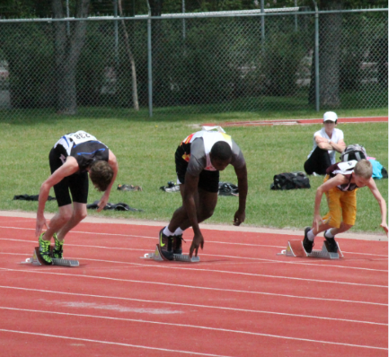
Talent should be identified based on potential talent (i.e., who will be good later) vs current talent (i.e., who is good now – resutls).
For instance, the athletes on the right are all the same age. Though the athletes on the right may be slower now because of his size, he may be faster once he passes his growth spurt. He shows potential talent because he displays correct technique but lacks strength, so that once he grows his power may be used in a correct way.
Other identifiers are things such mental and cognitive aspects as the ability and willingness to learn new skills, the motivation to train, and the ability to perform under pressure (see Appendix E for more).
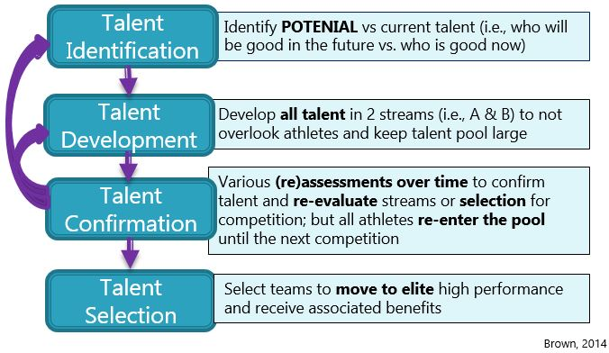
Talent should be
re-assessed
overtime in a process rather than a one-time trial.

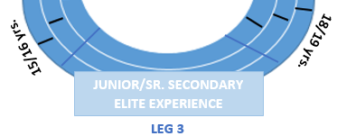
Youth:
Elite

Experience
Objective: Building technique and fitness while specializing in
athletics and gaining high performance exposure.

Ages: 16 - 17
School: Sr. Secondary

The athletes are now entering the last turn of the relay: leg 3. They have consolidated their skills and learned how to used them in competition in Leg 2. In leg 3, they will continue to progress those skills in more advanced training and try them in high performance setting. It should be noted that this competition is to gain exposure at the high performance setting so that they can cross the finish line strong in the final leg.
OVERVIEW

Types of Training: Formalized warm-up, training, session, and cool down.
Skills to Train: Athletics specific skills 1 or 2 disciplines along advancing fitness and mental skills.
Types of Competition: Competition experience at the high perforamcne level.
Number of Sports: 1-2
Duration of Training: 60 – 120 min
Frequency per Week: 4-6 sessions
Frequency of Other Sports per Week: 1-2 sessions
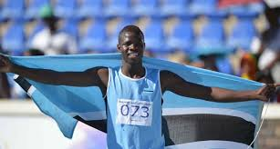
Duration Per Year: At this age, athletics generally
happens through school systems in Term 1 in both
government and non-government schools.Ideally,
athletics should run year round.
Key Stakeholders: BISA, ISSSA, Clubs,
Schools of Excellence

YOUTH TRAINING CONSIDERATIONS
PYSCHO-SOCIAL
PHYSICAL

- Formal periodized athletics training incorporating training sessinos of warm-up, main session and the 7 key factors of training, with regular competition warm-up routines.

- Physical fitness training tailored to the needs of their sport.

- Advanced event specific training in 1 or 2 events and can participatin in 1 or 2 other sports as cross training.

- Advance pyschological skills and integrated support servies, (i.e., physiotherapy, nutritionist, psycholoist, etc.,)

- Advance mental skills such as imagery, self talk, goal setting, focusing

- Foster independce through decision making, goal setting, self-awarenss and leadership
- Teach time management skills such as how to balance school, work and sport.
- Health eating and recovery tactics should emphasised whle cautioning disordered eating

YOUTH COMPETITION

Execution vs. Execution Under Pressure
Athletes are now ready to begin regular competition at higher performance level; however, the goal is not to win at all cost, but to learn how to win for the next stage.
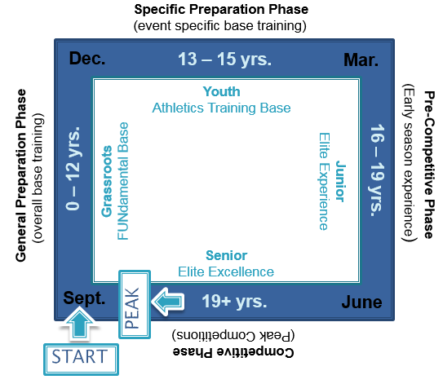
Similar to an annual plan, the purpose of early-season (or –age) competitions is not to win/peak because they may burn-out before their peak competition at the end of the season (or at a later age). Rather the goal is to gain experience for the important competitions later in their season (or life) so that this is not their first time in competition: winning when it counts.
Available Competition:
- Government Schools
- Private Schools
- BAA Competitions
- Potential Youth Nationals
- COSSASA
- African Youth Championships
- World Youth Championships
Remember: Only 5% of Youth World Medalists
become Olympic medalist.
Talent ID should follow the process outlined in the youth section by identifying potential talent.
Figure 1Life-long VS Yearly Plan: A Comparison. Life-long plan is
on the inside, and yearly plan (example) on the outside.
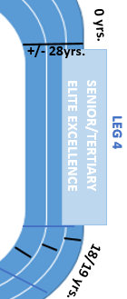
Junior/Senior: Elite Excellence

Objective: Optimizing technique and fitness in a specific event while aiming for excellence at a high performance level.

Ages: 18/19 +
School: Tertiary

This is the final leg of the athlete’s competitive career. They have learned their basics (leg 1), consolidated their skills (leg 2) and advanced those skills in leg 3. It is now time to fine-tune their skills and optimize their fitness and mental toughness to aim for excellence at the elite level.
OVERVIEW

Types of Training: Formalized warm-up, training, session, and cool down.
Skills to Train: Fine tuning athletics skills in a specialized discipline and optimizing fitness and mental toughness.
Types of Competition: Competition excellence at the elite level.
Number of Sports: 1 + recretional cross training
Duration of Training: 60 – 180 min
Frequency per Week: 5-6 days
Frequency of Other Sports per Week: 0-1 days
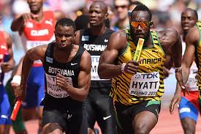
Duration Per Year: Athletes should train
year-round with breaks at the end of transition
phases (i.e., at the end of the 1st peak and 2nd)
Key Stakeholders: BAA, BOTESSA, BNOC

Senior Training Considerations
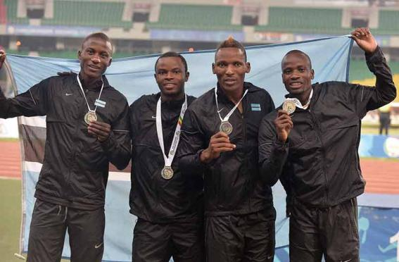
PHYSICAL
- Advanced periodized athletics training incorporating training sessinos of warm-up, main session and the 7 key factors of training, with regular competition warm-up routines.

- Physical fitness training tailored to the needs of their sport.

- Advanced event specific training in 1 or 2 events and can participatin in another recreational sport as cross training.

Senior Competitions
PYSCHO-SOCIAL
- BOTESSA,
- BoLesSwa
- FISU Games
- BAA Competitions
- African Senior Championships
- All African Games
- Dimaond Leagues
- IAAF World Relays
- IAAF World Challenges
- IAAF Inter-reional Challenge
- World Senior Championships
- Commonwealth Games
- Olympic Games

- Advance pyschological skills as imagery, self talk, goal setting, focusing

- Provide integrated support servies both at home, during training, and awy on comptition.(i.e., physiotherapy, nutritionist, psycholoist, sport science, career planning etc.,)
- Time, meda, and agent management, public speaking skills, and anti-doping education

- Life balance of athletics, school, career and family planing

- Transition to full professionalism (less reliance on

- Government, BNSC, BNOC, BAA

Athlete Retirement

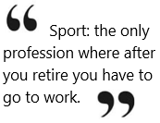
The next step in the cycle after elite excellence is athlete retirement. Athlete retirement can be one of the hardest transition stages in the development cycle. If an athlete identifies with being only an athlete and has no other skills to transition from sport, it can be difficult to continue with a career.
Athletes should be provided time and assistance for financial planning and professional development to prepare for retirement transition while noting that appropriate time away from training may also benefit performance by keeping the athlete fresh and avoiding mental burnout.
ALL AGES: RUNNING FOR LIFE

Ages: Any Age

Objective: Staying fit and healthy for life either for social, health, fun, or personal excellence reasons.

While the nation aims to send athletes to the Olympics, only 1% of the population will make the podium. Therefore we need to cater to the other 99%
Participants can enter and re-enter into the Running for Life Stream and Elite Stage at any time in their life after developping the Fundamental Movement Skills. Without these FUNdamentals it will be difficult to participatin in either elite or recreational sport.
SUB-STREAMS

- Recreation - participation for fun, social or health
- Personal Excellence – deliberate training for to achieve personal best (e.g. veteran’s competitions, masters series)
- Non-Athletic - coaching, administrating, officiatins, supporting

Several oppourtunties exist for Running for Life recreational and personal excellence streams in Botswana in the form of road running from 5 – 42 km such as
Kgale Road Race | Orapa 10 KM | Nsawazi Half Marthon
Diacore Marathon | PPC King of th Hill | Selibe Phikwe Half Marathon
Track and field has recreational oppourtunties through corporate events while cross-country has a natinoal series and some private races (i.e., Kgale Hill Scania Races).
The key to long term retention is not always determined by the persons sporting skills and abilities but wheather they had a positive, fun, and safe expereince in sport.

Appendix A
Botswana Long Term Athlete Development Model
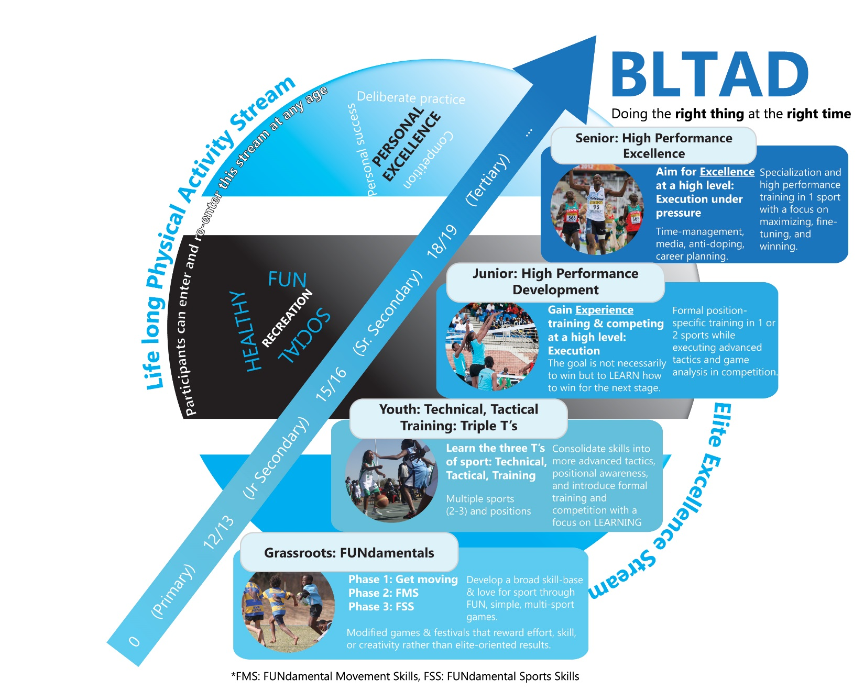
Figure 3:

Appendix B
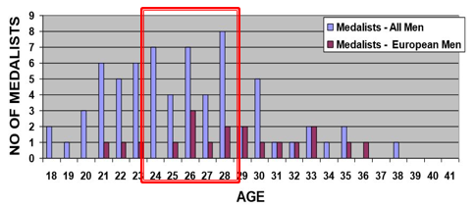
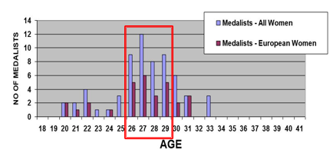
London 2012 Medalist Analysis
Figure 5: Average age of Male Olympic Medallist - London 2012 (Dick 2012)
Figure 4: Average age of Female Olympic Medallist - London 2012 (Dick 2012)

Figure 6: Percentage of Junior World Medallist from 2000-2010 who were Olympic Finalists or medallists at London 2012 (adopted from Dick 2012)

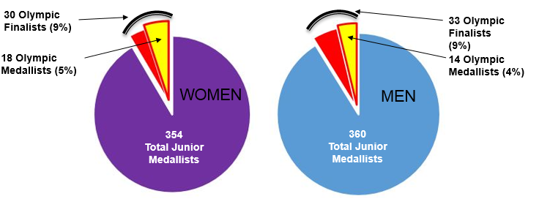

Appendix C
FUNdamental Skills
Table 1: FUNdamental Movement Skills (FMS)
Examples of FUNdamental Movement Skills
Locomotion Skills | Object Control Skillls | Balance Skills
Hopping  Skipping  Crawling  Jumping Leaping  Climbing  Poling  Running  Galloping  Bounding  Swinging  Wheeling | Kicking  Punting  Rolling (Ball)  Sticking object (hand or bat in air or on ground)n air or on ground)  Throwing  Catching  Stopping/Trapping  Dribbling (with feet)  Dribbling (with hands)  Blocking  Aiming | Balancing/Centering  Rolling  Dodging  Floating  Landing  Squatting-balancing  Sinking (in water)  Falling (through Air)  Spinning  Stopping  Stretching  Swinging  Twisitng  Standing on hands and head

Table 2: FUNdamental Athletics Skills (FAS)
RUN
Sprints  - Stride rate  - Knee lift  - Balls of feet  - Arm movement  - Speed | Starts  - Start commands  - Reaction time  - Standing start  - Crouching start  - Start low (drive) |  | Hurdles  - Trail leg  - Lead Leg  - Rhythm  - Run over vs jump  - Coordination | Relay  - Communication  - Open pass  - Show Target  - Passing  - Exchange zone |  | Race Strategy  - Start  - Kick  - Passing  - Lean  - Pacing
JUMP
Long Jump  - Standing LJ  - Approach  - Landing  - 3-5 step run up  - Rules (faults) |  | Standing Triple Jump  - Hop-scotch  - Hop-Step-Jump  - Landing  - Rhythm  - Coordination |  |  | High Jump  - Vertical Jump  - Approach  - Scissor Jump  - Back bend (from standing)  - Back bend (from approach)
THROW
Standing Shot Put  - Power Stance (preparation)  - Shift weight (delivery)  - “Put” not throw  - Follow through (recovery)  - Rules (Fouls, tuck in chin) |  | Standing Discus Throw  - Power stance (Preparation)  - Grip  - Fling not throw (Delivery)  - Follow through (recovery)  - Rules (Fouls, boundaries) |  |  | Javelin or Ball Throw  - Power stance (Preparation)  - Grip and arm positioning  - Approach  - Trajectory (release angle/position)  - Rules (Fouls, tip down)

Appendix D
Kids Athletics Reports Card
Figure 7: Kids Athletics Report Card (KARC) – Page 1

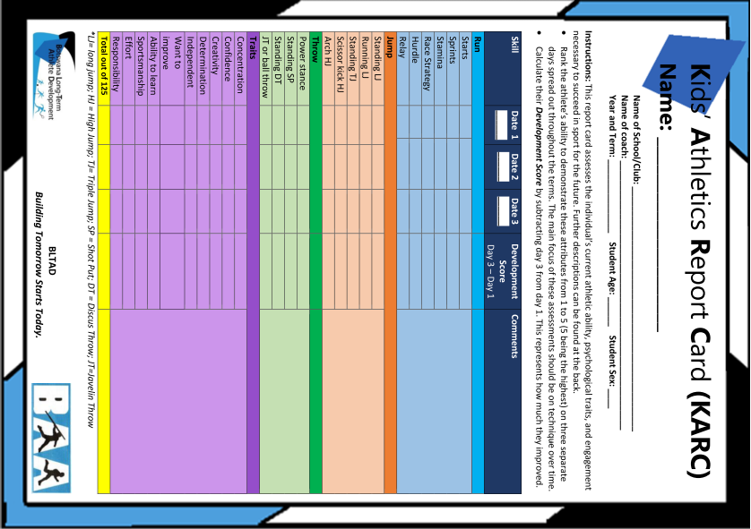

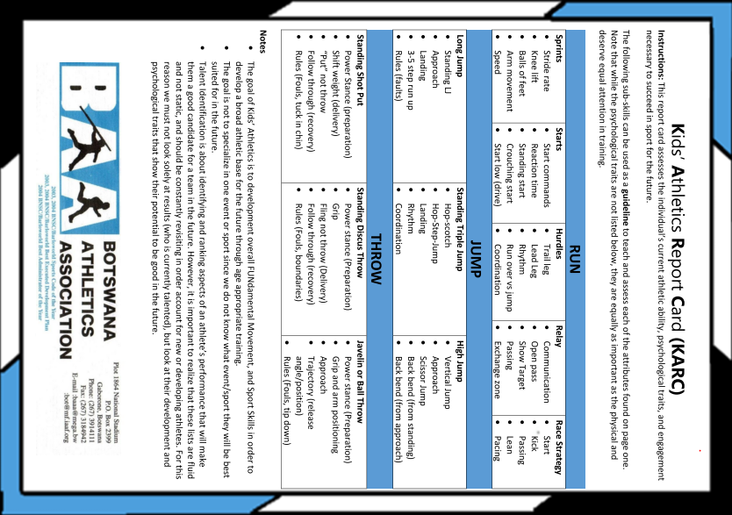
Figure 8: Kids Athletics Report Card (KARC)- Page 2
Appendix E
Talent Identification
Table 4: Potential Talent
Potential Talent
Ability to learn a new skills | Innovation | Confidence
Responsiveness to training | Problem Solving Skills | Concentration
FMS/FSS | Decision Making Skills | Determination
Sense of observation | Adaptive Strategies | Perseverance
Sense of judgement | Willing to improve (growth vs win) | Environmental/social factors
Tactical Awareness | Attitude | Self-management
Spatial Awareness | Sportsmanship | Self awareness
Effort | Responsibility | Enjoyment (intrinsic motivation)

Figure 9

