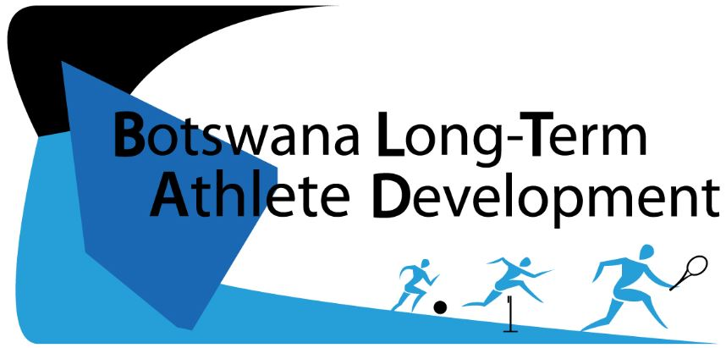
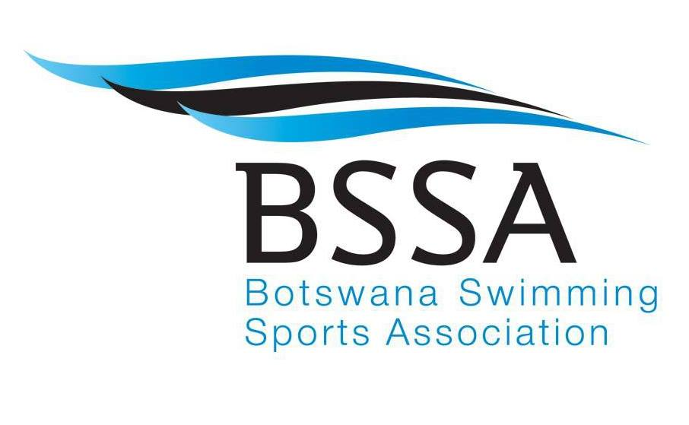
Today’s Strokes, Tomorrow’s Success
POOL TO PODIUM

A framework to guide swimming in Botswana towards lifelong participation and excellence at every level: from grassroots to the podium and beyond.

Created 2016

We acknowledge the support of
the Government of Botswana through the
Botswana National Olympic Committee

Key Stakeholders

Table Of Contents
Preface and Acknowledgements ……………………………. 4
BLTAD Pool To Podium Overview …………………………….. 6
BSSA Strategic Values Alignment ………………………………… 7
Key Factors ……………………………...……………………………….. 8
Sport System Review ……………………………...…………………… 15
Safety Considerations ……………………………...…………………. 19
Long-Term Nutritional Development ………………….. 20
Athletic Considerations ……………………………...…………… 21
Optimal Windows of Trainability …………………… 21
Peak Height Velocity ……………………………...……….. 23
Gender Considerations ……………………………...……… 24
BLTAD Stages ……………………………...……………………………… 25
BASIC STAGE (Minnow) ……………………………………… 26
Phase I …………………………………………………….. 27
Phase II ……………………………………………………… 29
INTERMEDIATE STAGE (Otter) ………………………………… 30
Phase I …………………………………………………............ 31
Phase II …………….…………………………………………… 33
ADVANCED STAGE (Whale) ………………………………………. 36
ELITE STAGE (Shark) ……………………………………………. 41
LIFELONG PHYSICAL ACTIVITY (Fins for Life) …….. 45
Athletes With a Disability……………………………...………………. 48
Retirement ……………………………...…………………………………. 49
Involuntary Loss of Sport ……………………………………………… 49
Collaboration ……………………………...……………………………… 50
BLTAD Committee ……………………………...……………………. 51
Appendices ……………………………...……………………………. 52
References ……………………………...…………………………. 62

Preface & Acknowledgements

The Botswana Swimming Sports Association (BSSA) is proud to present the Long Term Athlete Development (LTAD) model for swimming. This document is intended to act as a guide for coaches, administrators, and parents of the swimming community in Botswana, aiding in the development of athletes from their inception into the sport, to their quest for podium success.

Swimming in Botswana, operating under the direction of the BSSA, has experienced remarkable growth since its induction as a FINA associated sports federation in 2006. Many private schools in the country currently incorporate swimming into their educational curriculum, while several other private clubs currently institute learn-to-swim lessons, as well as provide competitive swimming instruction.

With such a promising start for swimming in the country, including the existing swimming infrastructure, Botswana is well positioned for future success in international competitions, up to and including Olympic participation. For these and many other reasons, the BSSA has recognized the need to ensure future growth in the sport of swimming, and the requirement of a structured framework. Such a document would be essential to the development of safe swimmers, for increasing participation rates, for talent identification, and for training medal hopeful athletes for competitive success.

BLTAD

BLTAD is a sports development framework that has been modeled after Canadian Sport for Life’s (CS4L) LTAD. An expert working group operating under Sport Canada created this world-renowned framework in 2005, which held the aim of promoting lifelong engagement in sport and physical activity, in addition to developing competitive success for particular sport codes. LTAD is a multi-stage training, competition and recovery pathway, which guides an individual’s experience in sport through all phases of the development process.

While Sport Canada’s model of the framework has been embraced by governing sport organizations around the world, each version has its own unique implementation. The BLTAD is different from the original Canadian LTAD, as it incorporates fewer stages in order to adjust for lower participant numbers in most Botswana NSAs. With that being said, the BLTAD continues to follow the accepted principles of growth, development, competition, training and recovery. The number and size of the LTAD stages has changed, however the comprehensiveness of the content and its implementation strategy remains.

Building Tomorrow Starts Today

Key Terms

BNOC – Botswana National Olympic Committee  BSSA – Botswana Swimming Sports Association  BNSC – Botswana National Sport Council  BLTAD – Botswana Long Term Athlete Development  FINA – International Swimming Federation  BOPSSA – Botswana Primary School Sports Association  BOTESA – Botswana Tertiary Education School Sport Association | CS4L – Canadian Sport For Life  CGC – Commonwealth Games Canada  NSA – National Sport Association  FINA – International Swimming Federation  NF – National Federation  BISA – Botswana Integrated Sports Association

Working Group

Mrs. Ruth Van Der Merwe : President – BSSA
Mrs. Bongie Ruele : Secretary General – BSSA
Mr. Thobo Moleko : Coach & PAISAC participant
Mrs. Tapiwa Masunga : Manager, Sport Development & Team Services – BNOC
Mr. Modise Mgadla : Sport Development & Team Services Officer – BNOC
Mr. Christopher Mazza : BLTAD/QESI Intern

_________________________ _________________________ _________________________
Mr. Ruth van der Merwe Mr. Solly Reikeletseng Mr Negroes Kgosietsile
President, BSSA Chairman, BNSC President, BNOC

Pool To Podium Overview

The BLTAD for swimming provides age-appropriate guidelines for training and competition for every age group. The goal of this framework is to guide athletes towards long-term participation and/or success from grassroots to the podium and beyond via Pool To Podium.

Across the world, many successful National Federations (NF) for swimming currently incorporate an LTAD framework to guide the development of their athletes. Each framework differs in its own way, just as this document will from CS4L’s initial LTAD release. Most importantly, this framework requires commitment and dedication from all stakeholders, from the governing bodies, the coaches who will be personally guiding the swimmers, the athletes themselves, and everyone in between. By engaging with this BLTAD framework, you are making a pledge of excellence, which should be made a high priority at each level.

The diagram below broadly represents all stages of the BLTAD framework. Each stage will be explained with detail in the following sections.

SHARK

Age: 18+

WHALE

Age: 15-18
FINS FOR LIFE

OTTER

Phase I: Age 9-13
Phase II: Age 13-16
MINNOW

Phase I: Age <6
Phase II: Age 6-9

Alignment to BSSA’s Strategic Plan
FAIRNESS – To ensure the equitable and just delivery of all training and athletic
competitions

The BLTAD may act as a guide for athletic growth, skills development and competition, however it will be the responsibility of all stakeholders to ensure that athletes are exposed to unbiased methods of judgment. This judgment may include reasonable competition structure, delivery of training sessions, and any other method that may aid in an athlete’s development.

INCLUSIVENESS – To ensure that all athletes are given the opportunity to realize their potential

The LTAD framework provides a platform where all athletes are afforded the appropriate direction and opportunity to progress at their own pace, en route to developing the required skills as their body is capable of doing so.

INTEGRITY – To provide an outlet for ethical and constructive skills development and competition

A successful LTAD framework will ensure that all athletes are engaging in ethical practices to achieve peak performance. In doing so, athletes will also contribute to the constructive development of other participants of the framework. This dedication to improvement will propel participants not only to elite athletic development, but also the growth of virtuous young men and women within the community of Botswana.

TRANSPARENCY – To encourage the honest distribution of knowledge with all participants

A successfully implemented framework will ensure that all stakeholders and participants are included and made aware of new knowledge as it is available. Both theoretical and practical knowledge are crucial for athletes to develop and realize their true potential. As a result, the open communication of knowledge must coincide with a constant effort to discover new information, practices, techniques and comprehension.

COOPERATION – To work together in a constant effort to improve as athletes and as members of the greater Botswana community

The provision of the BLTAD framework is a team effort. Through commitment from all stakeholders and participants, irrespective of a competitive or non-competitive sport context, consistent cooperation from all members is the cornerstone of an effectively implemented BLTAD framework. Such collaboration will ensure countless benefits, including athletic skill development, the promotion of a healthy, active lifestyle, the contribution to Botswana’s cultural development, and the continued growth of a well-rounded and proud nation, among many others.

Pool To Podium: 10 Key Factors
The implementation of a successful BLTAD model may be influenced by a variety of factors. Whether the ultimate goal is to achieve podium success and the development of elite athletes, or fostering participation and a healthy, active lifestyle for all Batswana, understanding how these factors impact sport on a daily basis is crucial to athletic and personal development.

1

The 10 Year Rule

Research has shown that the development of elite, highly skilled athletes takes years of dedicated practice and training. Ten years and 10,000 hours of deliberate training, to be precise. While each athlete will differ in his or her own unique way, no one, regardless of natural ability, will achieve international success without a commitment to training and practice. The time and hours outlined above have been identified as benchmarks, and equate to approximately 2.5 – 3 hours per day over a ten year period. There is no required starting age, and each athlete’s daily workload will differ based on their maturity, and participation in multiple sports.

Keep in mind that these figures are averages. Remember that athletes are NOT required to complete 10,000 hours of training in order to compete internationally. In addition, the 10,000-hour commitment will not guarantee international success, as parents, coaches, and the athletes themselves will also influence this achievement. Some athletes will progress slower than others, while some may experience accelerated development through special talent identification and development programs.

2
Physical Literacy

Nearly all sports require a common set of movement patterns or athletic skills, whether on the ground, in the air, or in water, as well as the control and manipulation of objects. The introduction of these fundamental skills is known as Physical Literacy, and is a crucial element for future athletic progression and development. In regards to swimming, along with the delivery of sport-related skills, water-based physical literacy also provides vital information about water safety, along with practical experience, which will remain valuable knowledge throughout the participant’s life. The most effective way to teach these fundamental skills is through games, while encouraging “free play” on the part of the athlete.

See appendix A for a list of the most basic Physical Literacy Skills for ground, air and water. See appendix J for a list of basic swimming skills and strokes.
3
Specialization

Further to physical literacy, swimming skills should be introduced at an early age, and should be refined through skill development as opposed to performance development. Aside from Early Specialization Sports (those that require complex movement patterns, ex. gymnastics, diving, figure skating), participants of an effective LTAD system SHOULD NOT specialize in any single sports too early because of the widely varying rate of growth and maturational development. If a swimmer is encouraged towards performance development while still refining his or her fundamental skills, this may hinder the opportunity for future competitive success.

Specific to swimming, athletes that have reached greater physical development in comparison to their age-group counterparts may exhibit more advanced skills than other children while they have a physical advantage, yet may fall behind as others reach the same maturity level. In fact, many elite swimmers do not reach their maximum performance until they are into their 20’s.
With a successfully implemented LTAD, children should be encouraged to try a wide range of sports that expose them to different physical literacy skills, as well as team sports in order to promote social interaction and personal growth.

Separate research by the US Olympic Committee and the German Olympic Committee has shown that specializing in a single sport prior to the ages of 10-12 years can result in early drop-out or retirement from physical and mental burnout, missing basic physical literacy skills, and injuries from overuse, among others.

Developmental Age
vs.
Chronological Age

4

The terms growth and maturation are often used synonymously, however each refers to specific biological activities, and are crucial to understand when implementing a successful LTAD.

GROWTH refers to the visible, progressive changes concerning body size, including height, weight, body fat, and muscle mass.

MATURATION refers to less observable system changes to the body, both structural and functional, including cartilage-to-bone progression and hormonal changes.

DEVELOPMENT refers to the interrelationship between growth and maturation as time passes, while incorporating an individual’s physical, mental, emotional and cognitive abilities.

CHRONOLOGICAL AGE refers to the number of years and months since birth. Children of the same chronological age may be vastly different in their developmental age.

DEVELOPMENTAL AGE refers to the physical, mental, emotional and cognitive maturity of an individual. While chronological age can be quantitatively assessed, it is the combination of chronological and developmental age that will provide an athlete’s relative developmental age, and dictate where this individual is situated along the BLTAD spectrum.

The BLTAD requires careful attention to an athlete’s development, and the identification of early, average, and late maturers in order to implement appropriate and effective training and competition structures.

Many international swimming programs focus on an individual’s chronological age when determining competition participation and athletic progression. However, athletes of the same chronological age may differ by 4-5 years in regards to their developmental age. This difference can act as a disadvantage to late maturers, while providing a significant advantage to early maturers. These early-maturing athletes may be mistaken as superior athletes when compared to their late-maturing counterparts, however it is often that the late maturers are in fact the ones who proceed with greater competitive success in the sport. The crucial element to consider is that each athlete must receive the same quality of coaching throughout the early LTAD stages. This allows each individual to develop at the appropriate rate for his or her body, and allows for the demonstration of their true potential after reaching their growth spurt.

5

Trainability

The three most important elements of sport at any level are training, competition and recovery. Research tells us that when a person trains regularly, they respond to a process of Stress – Recovery – Adaptation. The specific training activity acts as a stimulus that “stresses” a specific system in the body. If this training is followed by an appropriate rest or “recovery” period, that specific body system will effectively “adapt,” becoming stronger and better equipped to overcome that stress when it returns in future training or competition.

Trainability has been defined as an individual’s responsiveness when adapting to various training stimuli. Athletes will respond individually to different stimuli, adapting according to their body’s natural response. As a result, a well-designed structure of training and recovery is required and will ensure that the body’s systems continue to improve over time, resulting in a stronger and better-conditioned athlete. However, an improperly designed training program that places excess stress on the body with inadequate rest may lead to sickness or injury.

Principles of Training
The following six principles are important when considering the design of athletic training programs

- Specificity – An athlete will respond relative to the type of training undertaken (ex. Swimming training improves swimming performance, but not necessarily running performance)
- Overload – An athlete will respond well to progressively increased training loads (including volume and intensity). Consistent programs should be avoided, and can result in athletic plateau.
- Recovery – An athlete will make more effective progress in training when sufficient recovery and regeneration is built into the program.
- Variation – An athlete’s training regime must include a variation and sequencing of stressors over time in order to ensure that continual progress is made (planned training can include competition, recovery and regeneration periods).
- Individualization – An athlete will not respond to a given stimulus in an identical manner to another athlete. Variation in training programs and planning is required, especially for coaches of team sports.
- Reversibility – An athlete will begin to “de-train” or lose fitness when the original or maintenance stimulus has been removed. All training and environmental gains will be diminished once the athlete stops training, while the time frame for this decay depends on the frequency and intensity of training, and recovery time.

6
In addition to the development of physical, technical, and decision-making skills, training, competition and recovery programs should consider the mental, cognitive and emotional development of each athlete. As a major objective of Pool To Podium, it is imperative that athletes develop the mental skills necessary to control their physical performance. This includes emphasis on ethics, fair play, and character building throughout each stage of the BLTAD, and will ensure that athletes possess the foundation to excel in competitive and non-competitive sport.
7
Mental, Cognitive, & Emotional Development

Periodization

Periodization is the process of planning and organizing the various training processes into a logical and safe format, which fosters optimal performance development. In relation to LTAD, periodization connects the athlete’s current stage with the requirements of that stage. Through periodization, training components are broken into weeks, days and sessions, with specific sequences dependent upon training priorities and the timeframe available to improve performance.

The different lengths of training time broken down through periodization build on each other, and can be further defined as:

- Micro-cycles – shortest period; typically lasts 7-10 days in length
- Meso-cycles – intermediate period; incorporate several micro-cycles
- Macro-cycles – longest period; incorporate several meso-cycles

In addition to appropriate rest and recovery time during each training session, recovery cycles are also inserted into micro-cycles to allow for effective adaptation. These recovery cycles are dependent on the volume and intensity of the training being done, and may be inserted after 1, 2 or 3 work sessions, and again after 1, 2 or 3 work cycles.

For example:
- 1 work micro-cycle / 1 recovery micro-cycle (1:1 ratio)
- 2 work micro-cycles / 1 recovery micro-cycle (2:1 ratio) …and so on

The periodized training and competition plans are typically divided into the following phases:
- General Preparation Phase
- Specific Preparation Phase
- Pre-Competition Phase
- Competition Phase (Peaking & Tapering)
- Transition/Recovering Phase

Stakeholder Alignment & Integration
There are a number of stakeholders that are vital to sport in Botswana. The best way to achieve a complete and effective sport system is through complete alignment, commitment and involvement by all stakeholders. Special concern must be given by the core leadership of sport in Botswana to manage and drive national processes. These essential members are:

- Botswana National Olympic Committee  - Botswana National Sport Commission  - Local Schools and Sport Clubs | - Ministry of Youth Empowerment, Sport & Culture Development  - University of Botswana

9

Competition is an important element of an effective LTAD program. More specifically, appropriate competition planning for individual athletes is an effective tool for their development in the sport. At some stages, skill development and physical literacy takes precedence over competition, however embracing the competitive aspect of sport is crucial to one’s progression in that particular sport.

The following considerations should be given when designing a competition calendar:
- Frequency and length of competitions should be unique to each stage of the LTAD
- The level of competition should be appropriate for the athlete, and will aid with technical, tactical and mental development
- Specific competitions should be selected by the athletes and coaches based on the athlete’s particular needs

See appendix B for a recommended ratio of training to competition. Remember that each athlete should have their own unique competition schedule, based on his or her unique sport and development. In addition, optimal numbers and locations of competition in Botswana will be affected by low participation numbers, which will require further modification of individual athletic competition calendars.

While competition is one of the best methods to further skill development and mastery, always remember that LTAD is designed to protect athletes from early exposure to competitions that are too high in quality or intensity, which pose potential risks to their long-term development.
Planning for Competition
8

Talent Identification, Talent Selection & the Birth Month Effect
During the LTAD process, there will reach a stage where sport organizations will seek to identify and select the most talented participants in their particular sport and provide special opportunities for them to develop under expert coaching, and a more controlled environment than they may receive in their local community, school and/or club.

As a result, it is important to ensure that participants are being tested at appropriate ages in order to identify talent based on the best anatomical, physiological and psychological attributes that might indicate above-average potential. Some important differences to consider are:

Talent Identification
Refers to the direct identification of potential talent in one (1) or more sports, based on testing markers that are used to predict future talent. With the exception of early-specialization sports (as previously discussed – see Specialization), sport organizations should not attempt to predict and identify future talent until at least 14 or 15 years of age (the end of the Intermediate Stage - Otter, or the beginning of the Advanced Stage - Whale).

Talent Selection
Refers to the selection of potentially elite athletes based on their current performance levels against participants already participating in that sport. This typically occurs at championship events or selection trials (ex. Try-outs). Talent selection is not recommended to begin until Phase II of the Intermediate Stage.

Birth Month Effect
Refers to the phenomenon that children who are born in a particular sport’s peak season may have a greater chance of being identified as potentially talented athletes. This is caused by the large range of growth and development in children and adolescents, and gives those born in the early months of the season an advantage over those born near the end. This may result in smaller and younger athletes being overlooked, even though they may eventually return better performance results, and can be counteracted through the following:
- Eliminating the “All-Star” selection process and restricting talent identification and selection to the end of the Intermediate Stage
- Host multiple selection phases throughout the year for the late Intermediate Stage and early Advanced Stage
- Provide opportunities for try-outs in the Advanced and Elite stages, so potentially overlooked athletes have a chance to re-enter the process
10
Sport System Review

The following review was conducted through an analysis of the BSSA’s 2028 Strategy and questionnaires delivered to swimming clubs in Botswana.

SWOT Analysis (Strengths, Weaknesses, Opportunities, Threats)

Internal |  | External
Strengths | - Access to 2 Olympic sized pools  - Availability of facilities  - Good Media Relations  - More funding available from Government  - Affiliates  - Committed Volunteers  - Good governance - Well Organized Code  - Effective development programmes  - Frequent Opportunities for athletes to compete regionally and internationally  - Value of the sport being recognized by mother governing/bodies and the public | Opportunities | - Programmes from mother bodies and stakeholders  - International programmes  - Willing corporate sector  - Support system; i.e. parents and the community  - Non-registered clubs and individuals in different aquatic codes who could be recruited into the BSSA  - Government and other schools not involved in swimming, who could also be recruited into BSSA activities and programmes  - Facilities – Unused
Weaknesses | - Inadequate high level performance facilities  - Lack of pools/facilities in public schools  - Lack of winter facilities  - Lack of BSSA owned facilities  - Limited number of registered pools  - Under-utilization of available facilities  - Inefficient/inadequate structure  - Lack of organizational structures for the other aquatics disciplines  - Inadequate skilled/trained personnel (administrators and technical officials)  - Inadequate funding  - No major sponsors/partners  - Non-participation of most institutions | Threats | - Declining availability of water in Botswana  - Increasing cost of the sport to athletes  - School curriculum that continues to be out of alignment with the sporting calendar  - Location of clubs/affiliates around the country (distance)  - Myths around the sport of swimming  - Brain drain  - Labour relations issues  - Drug abuse in schools  - Dropouts – Other countries; Other Sports; Culture; puberty  - Politics in sport

The preceding SWOT analysis highlights several key items that should be improved and exploited in relation to swimming in Botswana. Below is a list of elements that identifies where this particular sport code currently succeeds, as well as areas where it is lacking, and methods to improve these capacities.

Current Facilities
As identified in the SWOT analysis, Botswana currently possesses a surprisingly large collection of swimming facilities. These facilities range from dedicated learn to swim pools (shallow depth), private school pools, public facilities (local gyms, etc.), race-ready pools, as well as two Olympic sized pools.
While these facilities exist in abundance, they are not being used to their fullest capacity and to engage all members of the community. While many private schools have access to their own facilities, public schools and underserved institutions (local orphanages) are not receiving the same access. The BSSA should focus on engaging this population while utilizing the facilities at its public disposal, while also collaborating with new local partners.
In addition, funds should be allocated for the development of new facilities or the transfer of ownership of underused facilities. These pools would then be possessed by the BSSA for use in addressing underserved populations and the development of winter facilities.

Coaches & Trainers
Several former swimmers in Botswana become integrated with their previous clubs in a coaching or training capacity. These individuals demonstrate commitment and dedication to the sport, and provide a unique pool of available instructors.
The roles of these former swimmers should be expanded, as they may provide an ideal pool of coaches for public and underserved institutions. In addition, there remains a large population of former swimmers who have not been engaged in this capacity (for a multitude of reasons, including lack of financial resources). Volunteer opportunities for these individuals should be promoted as a means to build an individual’s resume/CV, while also contributing to the development of swimming in Botswana.

Stakeholder Education
Parents/caregivers, teachers and some swimmers themselves do not possess sufficient information about their development as an athlete, including elements related to proper nutrition, hydration, and physical, cognitive and emotional development.
Knowledge sessions should be held and integrated into learn to swim programs to held educate all stakeholders on the importance of crucial developmental issues. In addition, access to this BLTAD framework should be widespread, and clarification on its key items should be made available by knowledgeable coaches, trainers and the BLTAD Committee (see page 51).
Parents/caregivers should play a vital role in athlete development, as they will dictate the level of participation for their children during their youth and adolescent years. However, the engagement of these stakeholders should be adequately managed, as the separation between coaching and parenting must be established.

Partners/Sponsors
Large populations of potential partners (and as a result, financial and other resources) do not play a large enough role in the development of swimming in Botswana.
Engaging these potential partners would greatly aid in the development of new facilities (including dedicated high-performance sport facilities for elite athletes), the acquisition of more advanced equipment, and the implementation of key BLTAD elements.

Adult Swimming Development
Many adults in Botswana have inadequate swimming knowledge, which not only limits their athletic participation in the sport of swimming, but also restricts their understanding and possession of a crucial life skill.
While the BLTAD ideally engages athletes from a young age through to their participation as elite swimmers, any member of the population should have access to swimming resources, while receiving the opportunity to align with this framework. Potential BSSA-owned facilities or other public venues should be used as learn to swim forums for the older population on a frequent basis. This also provides an opportunity to engage volunteer instructors.

Safety
Safety requirements of coaches and instructors vary across the country, as qualifications differ from club to club.
While it is beneficial for each club to have unique differences, safety qualifications should be standardized across the country. CPR and First Aid training should be mandatory of all coaches, while fully stocked and certified first aid kits should be available at each facility. Parents/caregivers should also be advised to receive CPR and First Aid training, however this would be optional.

Talent Identification
Oftentimes, swimmers that reach puberty earlier than their peers will be viewed as more advanced swimmers, receiving more attention from coaches and instructors as a result.
The BLTAD provides recommendations for talent identification and sport specialization, which should be utilized by all coaches and trainers in Botswana. On many occasions, late-developing swimmers will reach higher levels of elite performance in comparison to their early-developing peers. With an equal division of coaching, all swimmers will receive adequate instruction, and in turn, the opportunity to reach their full potential.

Economic Considerations
In a scenario where the country’s economy falters, methods should be implemented that will allow for the sport of swimming to continue to operate according to the BLTAD.
Developing committed volunteers and engaging with dedicated sponsors will ensure that swimming in Botswana has a solid foundation of human and financial resources to continue implementing the BLTAD framework.

BSSA High Level Targets and Bridging the Gap

As part of the BSSA’s 2028 Strategy, the following have been identified as high-level targets to strive for in an effort to improve Botswana’s international competitive success:
- Corporate Governance  - Resource Mobilization | - Awareness  - Sports Development

In addition, the following items should be addressed in order for swimming in Botswana to shift from its current state to the desired 2028 position:

- Engage a PR resource  - Engagement through social media  - Partner with business community  - Grassroots development programmes  - Review Organizational Structures  - Partnership with the Government to promote water safety  - Partnership with the Government to promote water safety  - Construction of a long term athlete development programme  - Develop monitoring and evaluation instruments for the executive committee  - Engage in fundraising with stakeholders and sponsors  - Engage the media to create national awareness on aquatic sport | - Design a national grassroots level development plan  - Engage stakeholders to implement national development plan  - Develop programmes to maximize use of the existing swimming facilities  - Develop stakeholder engagement policy  - Develop Media/Marketing Policies/Programmes  - Organizational Assessment o Restructuring o Sub-Committees  - Engage CANA (Regional) and FINA (international)  - Engage Govt./Ministries (NDP, Education, Alcohol Levy)

For more information on the present state and future goals of swimming in Botswana, refer to the BSSA 2028 Strategy.

BSSA Mission Statement

We aim to harness the support of all aquatic development (STAKEHOLDERS) to achieve a high level of sporting excellence

Safety Considerations

First Aid/CPR

All sports carry inherent safety risks, however swimming adds an additional hazard, as a body of water must be treated with caution and awareness by coaches, parents and athletes at all times.

It is recommended that all coaches (and in turn, parents and athletes themselves) be trained in proper First Aid and CPR practices, so that they can take action in any situation that requires an immediate emergency response. In addition, proper lifeguarding techniques may be helpful to learn for use as a coach and to help build an individual’s resume/CV.

Swimming Safety Tips

Swimming provides an incredible opportunity for fitness and fun, whether for athletic development or simply for leisure. However, it can also be a very dangerous activity. Always remember that safety is the top priority when participating in swimming activities. Follow these tips to keep coaches, parents and swimmers as safe as possible:

- Underage or inexperienced swimmers should always be supervised by a coach or lifeguard when swimming
- Always swim with a partner
- Avoid distractions when supervising children around water
- Teach children to ask permission before going near water
- Teach children to always walk when around a pool, never run
- Teach children to behave with others when in water. Rough play may result in injury
- When conducting lessons with children (aged 3-6 years old), the child-to-teacher ratio should never be more than 5:1
- Keep a cell phone handy, and know the local emergency number
- Drink plenty of water before, after, and during swim breaks, even if you are not thirsty

Water safety is crucial for competition, training, and for life!

Safety tips adapted from the American Red Cross’ website
“Pit Crew”

Athletic development must give special consideration to the daily preparations that athletes take to ensure their body is ready for physical exertion. Proper stretching routines should be incorporated into pre- and post-training and competition regimes.

In addition, proper nutrition is vital to the cognitive and physical development of young athletes, as well as the promotion of a healthy lifestyle for all age groups. The following page depicts the concept of Long-Term Nutritional Development (LTND). It is recommended that LTND or another approach to nutritional consideration be incorporated into the LTAD model, in relation to the daily preparations taken by coaches and parents, AKA the “Pit Crew,” or by the athletes themselves.

Long-Term Nutritional Development

Long-Term Nutritional Development (LTND) has been researched as a complementary strategy to the ever-growing LTAD models. While physical training and competition has been discussed as it relates to athletic development, appropriate habits of food selection and nutrition timing is crucial to the development of young athletes, and to the foundation of a healthy lifestyle for individuals of all ages.

The nutritional needs of youth athletes relate to areas such as prevention and management of injuries, the regulation and exertion of energy (for training and competition), and to the enhancement of athletic performance, among others.

The growing number of participants and recognition for the benefits of a healthy, active lifestyle has created a need and greater focus on training and development, and the creation of LTAD frameworks across the world. The LTND model was created to function in collaboration with a sport code’s given LTAD model and is important to acknowledge, as proper nutrition is a growing strategy to enhance development.

As individuals progress through the LTND model, emphasis shifts from the acquisition of knowledge about meals and nutrition (ex. Breakfast provides energy and can reduce obesity) to responsibility being placed on the athlete to monitor, select and moderate his/her own food appropriately.

The table below depicts the similarities between standard LTAD and LTND models. Note that the first two stages of LTND coincide with the physical literacy component of LTAD. Eat to develop and learn to eat occur during periods of peak brain maturation.

Developmental Focus | Typical Age Span | LTAD Model | LTND Model
Physical Literacy | Males: 6 – 9 Years Old  Females: 6 – 8 Years Old  Males: 9 – 12 Years Old  Females: 8 – 11 Years Old | FUNdamentals  Learning to Train | Eat to Develop  Learn to Eat
Physical & Mental Capacity | Males: 12 – 16 Years Old  Females: 11 – 15 Years Old  Males: 16 – 23 Years Old  Females: 15 – 21 Years Old | Training to Train  Training to Compete | Eat to Grow  Eat to Train
High Performance | Males: 19 Years and Older  Females: 18 Years and Older | Training to Win | Eat to Win
Table and LTND information adapted from Lloyd & Oliver’s Strength and Conditioning for Young Athletes: Science and Application
Athletic Considerations

Optimal Windows of Trainability

An athlete’s overall fitness level may be influenced by a number of factors, five of which should be considered vital components when considering LTAD:

- Stamina (Endurance)  - Strength  - Speed | - Skill  - Suppleness (Flexibility)

Fitness Component | Optimal Window for Girls | Optimal Window for Boys | Implication
Stamina (Endurance) | OWT occurs at the onset of Peak Height Velocity** (PHV). Aerobic capacity training is recommended BEFORE athletes reach PHV. Aerobic power training should be introduced progressively after PHV and growth rate begins to decelerate. | OWT occurs at the onset of Peak Height Velocity** (PHV). Aerobic capacity training is recommended BEFORE athletes reach PHV. Aerobic power training should be introduced progressively after PHV and growth rate begins to decelerate. | Prior to PHV, lower level aerobic training is advised. Higher intensity sustained aerobic work closer to VO2Max is not advised (for large percentage of total training time) until after PHV has been reached
Each of the above components should be considered trainable, meaning that each can improve or decline at varied rates in response to training. In addition, each component has an optimal window of trainability (OWT), meaning that if children or adolescents attempt to train any of these components too early in their development age they will return minimal results in relation to the time and effort used in training.

The table below indicates the OWT for boys and girls, for each of the five vital components of fitness.

Table adapted from the BLTAD Book and Swimming Canada LTAD
Strength | OWT for Strength begins immediately AFTER PHV or at the onset of menarche. | OWT for Strength begins 12-18 months AFTER PHV has been reached. | Strength gains can be made with training before PHV for both boys and girls. However this is more from muscle recruitment changes and neurological adaptation rather than muscle/tendon growth adaptations.
Speed | For girls, there are two windows of opportunity. The 1st occurs between the ages of 6 – 8 years of age and the 2nd occurs between the ages of 11 and 13 years of age. | For boys, there are two windows of opportunity. The 1st occurs between 7 and 9 years of age and the 2nd occurs between the ages of 11 and 13 years of age. | For swimming, where pace is an important component, this is when speed, speed technique and speed drills will be most effective and reap the most rewards.
Skill | OWT is between 8 and 11 years of age. | OWT is between 9 and 12 years of age. | Both of these intervals are relatively slow growth periods, meaning body position, coordination and movement through space are relatively constant. As a result, skill & coordination, and hand/eye & foot/eye coordination can be optimized. However, be prepared for an apparent (temporary) decline in skill execution when individuals approach PHV in the few years after this window.
Suppleness (Flexibility) | OWT occurs between 6 and 10 years of age, but should be continued through all ages of training. | OWT occurs between 6 and 10 years of age, but should be continued through all ages of training.

Peak Height Velocity

Peak Height Velocity (PHV) refers to the maximum rate of growth in stature during the adolescent growth spurt. The age at which PHV is reached (called Age at PHV) is an important measurement point in a LTAD program because it serves as a basis for readiness for different types of training.

The implication of PHV on coaches and teams, specific to swimming in this case, is that on any one team or training group, coaches may have early, average and/or late maturers. As a result, an effective LTAD program should incorporate PHV monitoring as part of a regular athlete-monitoring program. Three key elements should be included in PHV monitoring:

- Standing height, sitting height and arm span (fingertip to fingertip, with arms outstretched) measurements should be taken and tracked in an organized manner
- Recognition of the start of the growth spurt
- Point of maximum height change

Measurements should be taken at consistent times (ex. Mornings) and in consistent intervals (ex. Every 3 months). Once PHV is reached, a growth deceleration will commence. Growth should continue to be monitored for 24 – 36 months after PHV.

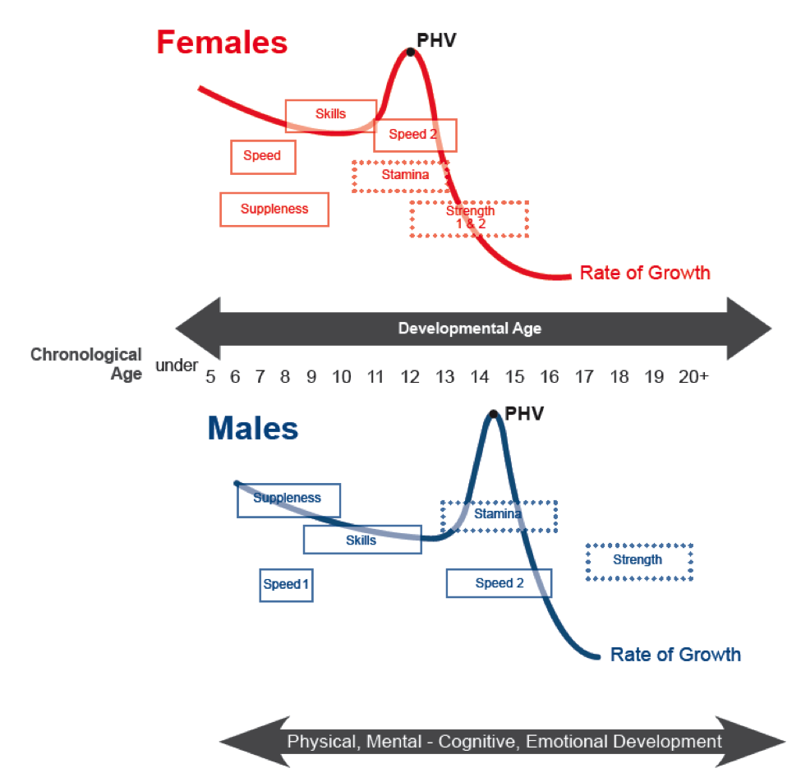
The table below shows the Optimal Windows of Trainability (OWT) for males and females, along with the onset of PHV. Of the five vital components of fitness, the OWT for stamina and strength are based on the variable onset of the growth spurt and PHV, while speed, skill and suppleness are based on chronological age.

Gender Considerations

Across many developmental platforms, from an educational context to athletics, gender differences exist that have created a need for special considerations between boys and girls, so to help foster their optimal progression.

The following is a list of important gender-related differences that coaches and parents must consider when conducting athlete-training programs. We must, however, be sure to attempt to balance these differences, without allowing them to create improper stereotypes or false generalizations.

Factor – Puberty Differences
Approach – In this instance, boys are granted a developmental advantage, as the testosterone produced by their body will allow them to rapidly increase muscle and decrease body fat. For girls, the excess estrogen produced will cause their body to break down protein, and may have a primarily negative impact on athletic performance. It is for this reason that training programs for girls should focus primarily on strength and muscle development, so to balance the body’s natural changes.

Factor – Peak Developmental Periods
Approach – This factor relates to the period when young athletes enter their growth curve. Referring to the PHV chart on page 23, note that girls tend to mature about two years earlier than boys. When entering this growth curve (typically age 11-13 for females and 13-15 for males), young athletes will have the opportunity for substantial aerobic growth, or in the efficiency of the body’s cardiovascular system. The consequence of the age difference between boys’ and girls’ entry to the growth curve is in the way that their bodies will develop physically. As a result, boys and girls must be given special attention by coaches and parents during this phase of their development, so to properly take advantage of their natural growth.

Factor – Psychosocial Development
Approach – During development, boys and girls will demonstrate differences in various psychosocial characteristics. These characteristics should be monitored closely by coaches and parents, and action should be taken that will foster the appropriate response by the athlete in the context of training and competition. These characteristics include self-confidence, where males will tend to exhibit stronger feelings of self-competence and ability, resulting in higher levels of participation and motivation; goal orientation, where males tend to be more results-driven and females more personal-standard oriented, resulting in more successful experiences for females (only one swimmer can “win” each individual race!); and affiliation needs, where females tend to exhibit a greater desire for affiliation and males appear motivated primarily by competition. These differences must not be neglected, but rather embraced so to foster the best development for each individual athlete.

Pool To Podium Progression

1

BASIC STAGE
(MINNOW)
Phase I (Age <6)
Phase II (Age 6-9)

2

INTERMEDIATE STAGE
(OTTER)
Phase I (Age 9-13)
Phase II (Age 13-16)
3

ADVANCED STAGE
(WHALE)
(Age 15-18)

4

ELITE STAGE
(SHARK)
(Age 18+)
5

LIFELONG PHYSICAL
ACTIVITY
(FINS FOR LIFE)

1

Number of Sports: Multi-sport participation (encourage FUNdamental sports – athletics, gymnastics, swimming)

Types of Training: Assorted sporting activities, athletic games in groups

Skills to Train: FUNdamental movement (see appendix A), flexibility, water mobility & balance, proper breathing techniques when in and around water

Duration of Training: 45 minutes per session

Swimming Frequency: 1-2 sessions per week

Non-Swimming Frequency: 1-3 sessions per week

Types of Competition: Minimal or no competition at this stage. Highest level of competition should occur between participants during learn-to-swim lessons, where athletes will compare their actions against others in a constructive manner.

See appendix E for a list of important responsibilities for the various stakeholders of the Basic Stage

Basic Stage

“MINNOW”

Male: Ages 0-9  Female: Ages 0-8  Schools: Pre-School / Daycare | Key Stakeholders:  Parents Coaches Ministry of Education BNSC BSSA BOPSSA Sport Clubs Ministry of Youth, Sport & Culture
Key Considerations:

ACTIVE START – Build enjoyment and a love of being physically active
PHYSICAL LITERACY – Learn all FUNdamental movement skills
Build mastery of more complex motor skill patterns from basic motor skills
Build confidence and self-esteem
Teach basic water safety skills

Primary Objective:
Develop FUNdamental athletic skills, teach water safety proficiency and build confidence in an athletic context

Basic Stage

Phase I (Active Start)
Male & Female Age: <6 Years Old

At this phase of the BLTAD, the focus should be on the development and mastery of basic and relevant physical literacy skills. The important swimming skills to develop at this phase are:

- Safety around a body of water  - Proper breathing techniques when in water  - Full-body submersion in water | - Floatation (technical front & back float)  - Gliding (technical front & back glide)

While the eventual hope is for an increase in swimming participation, it is important for children to experience different sports and develop appropriate FUNdamental skills and knowledge through exploration. As a result of the generally shorter attention spans in children, amusement through sports and social interaction are important tools to use throughout this phase.

Learn-to-swim lessons should be inclusive, where coaches allocate consistent time to each swimmer, regardless of how quickly each individual is progressing. Competition should be avoided at this phase, however children should be allowed to compare their in-pool actions against others. This can be accomplished by choosing individual swimmers to demonstrate various activities. An environment that is overly competitive at this phase may pose risks such as injury, learning improper from, and future discouragement from the sport.

While injuries may occur at any stage of the Pool to Podium framework, the creation of an athletic environment that fosters safety can help greatly in preventing them. As noted in the section on Safety Considerations (Pg. 19), coaches should be trained in proper first aid and CPR techniques, while fully stocked first aid kits should be present at each swimming facility.

Additionally, stakeholder involvement is vital to the success of this phase and the development of FUNdamental skills. Coaches, parents, child caregivers and early childhood educators must foster an environment that promotes the improvement of these skills through games and “free play.” The BSSA must also ensure to keep these stakeholders involved throughout this and other stages of the BLTAD, so to maintain the continued growth and development of children and athletes in Botswana today and for the future.

Basic Stage

Components of an Effective Learn To Swim Program:
- Non-competitive environment
- Availability of appropriate learn to swim equipment (floating boards, noodles, sinking toys, etc.)
- No specific specialization
- Enthusiastic instructors
- Promote proper nutrition and hydration (swimmers and coaches should drink water throughout each lesson)
- Track the progress of each individual swimmer during each lesson (see appendix C for an example of a lesson-by-lesson tracking sheet, and appendix D for an example of learn to swim level progression…please note that levels 6 & 7 in this chart should not apply to children in the Basic Stage of the BLTAD)

- Unstructured AND structured swimming exercises
- Non-judgmental environment
- Encourage children to invent games and experiment in the pool so to better understand the ability of their bodies
- Relatively small class sizes (Coach : Student ratio of no more than 1 : 5) and adjust the level of challenge for each individual swimmer
- Water submersion confidence must be achieved prior to floatation and gliding progression
- Confidence building activities are important for athletic development
- Swimmers should be allocated free time during each lesson to test their abilities

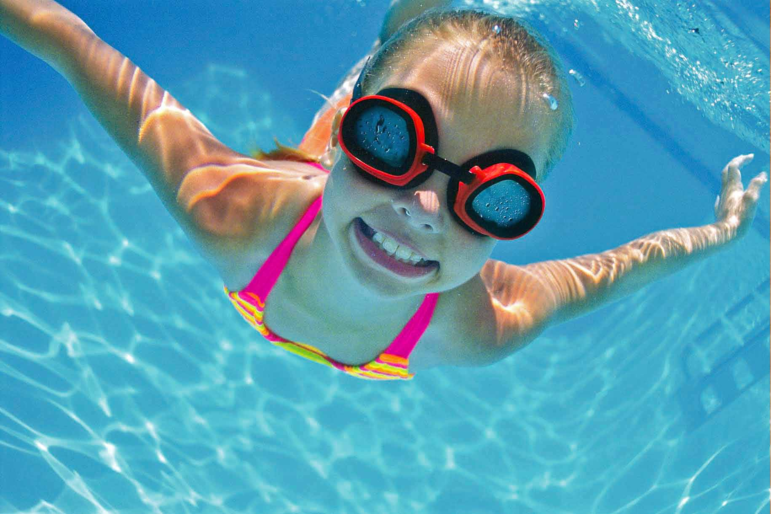
Swimming for Facts

Near the latter periods of this stage (ages 6-9), both boys and girls can experience rapid growth of mental capacity, coordination and motor skills. It is for this reason that the proper introduction of FUNdamental skills is crucial to an athlete’s current and future development.

Throughout this stage, boys and girls will experience mental and physical progression at different rates, which makes it crucial for coaches and parents to be supportive, inclusive and encouraging to all young athletes.

Basic Stage
Phase II (Physical Literacy & FUNdamentals)
Male & Female Age: 6-9 Years Old

Similar to Phase I, the development of physical literacy skills and FUNdamental water abilities are a priority in Phase II. However, part II should focus on slightly more advanced swimming skills, including technically sound floatation and gliding, and an introduction to basic strokes (front crawl, back stroke, breast stroke) for those who have successfully achieved the preceding foundational skills (breathing, submersion, floating, gliding). In addition, swimmers should be introduced to proper race start methods, and in-water turns. Throughout the Basic Stage, movements should be repeated by both athletes and coaches, and directions should be simple and easy to follow. Finally, basic life skills such as perseverance, enthusiasm, concentration, stress-management, creativity and cognitive development should be instructed and emphasized at the Basic Stage.

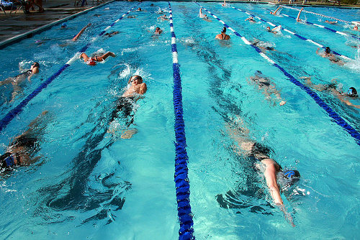

To-do list for the Basic Stage

Children should learn about
basic relaxation and energizing
skills

Children should learn about
creative imagery

Children should develop a
sense of self-confidence
Swimming for Facts

Instructors at the basic stage should focus on the development of athletes’ ABC’S: Agility, Balance, Coordination, & Speed. Paired with the development of FUNdamental movement skills, the ABC’S will provide athletes with a proper foundation for growth today and for the future.

Children should be recognized
for their successes and informed
of their mistakes, with constructive
methods for improvement

2

Intermediate Stage “OTTER”

Male: Ages 10-16  Female: Ages 9-15  Schools: Primary | Key Stakeholders:  Parents Coaches Ministry of Education BNSC BSSA BOPSSA Sport Clubs Ministry of Youth, Sport & Culture
Key Considerations:

LEARN TO TRAIN – Discover basic skills of physical and cognitive training
Continue to build and promote nutritional knowledge
Continue to develop ABC’S – Agility, Balance, Coordination, Speed
TRAIN TO TRAIN – Introduce training patterns and consistency
Promote strength and aerobic development during onset of the growth spurt
(Typically occurs during Phase II)

Primary Objective:
Introduce athletes to the importance of training and proper nutrition, while preparing their body for optimal periods of growth and development

Types of Training:  PHASE I High repetition, low intensity  PHASE II High volume, aerobic capacity building from onset of PHV to highest PHV  Skills to Train: Water mobility, technical floatation, gliding and development/mastery of strokes  Duration of Training:  PHASE I 60-90 minutes per session  PHASE II 60-120 minutes per session | Swimming Frequency:  PHASE I 4-6 sessions per week (4-7 pool hrs)  PHASE II 6-12 sessions per week (12-24 pool hrs)  Non-Swimming Frequency:  PHASE I 2-3 different sports/sport activities each chronological year  PHASE II 1-2 different sports/sport activities each chronological year
Types of Competition:
PHASE I Introduction to competition structures/events; focus on competitive rewards based on skill development
PHASE II Introduction to racing tactics; focus on competitive rewards based on distance and stroke development; emphasis on proper warm-up, cool-down, and pre/post-race nutrition

See appendix F for a list of important responsibilities for the various stakeholders of the Intermediate Stage

Intermediate Stage

Phase I (Learn to Train)
Readiness to advance determined by skill competency and measured increase in PHV
Male & Female Age: 9-13 Years Old

At this phase of the BLTAD, the focus should be on the development and mastery of crucial competition-based skills that will prepare athletes for future success. The important swimming skills to develop at this phase are:

- Strokes (development and mastery of technical body position and stroke execution)  - Race starts | - In-water turns  - Underwater skills  - Further refinement of swimming skills from the Basic Stage
As this phase will include an athlete’s physical and mental preparation for the growth spurt, increased emphasis must be given to the consistent and frequent demonstration of technically sound swimming skills. This will ensure that the body has acquired the proper skills to allow for optimal athletic development during peak growth periods. The instruction that an athlete receives during this phase (and for each proceeding stage) should be from a swimming expert or qualified competitive swimming coach.

This phase is an important step in regards to the physical development of athletes, which means that proper nutrition, flexibility (achieved through pre- and post-lesson stretching), and the further in-water and dry land development of the ABC’S should be encouraged. These elements will contribute to the ideal development of a growing individual’s motor control abilities.
Swimming for Facts

Competition during both phases of the intermediate stage should act as an introduction for the athletes, and will provide the foundation for future competitive success.

In addition, athletes should begin engaging in competitive activities or events with others who are at most one above or three below the athlete’s current level of competition, in order to challenge and practice his/her skill acquisition, respectively.

Similar to the Basic Stage, the concept of “free play” should still apply to the Intermediate Stage, as it will provide athletes with the opportunity to further test the abilities of their bodies. During in-water sessions, coaches should effectively demonstrate the ideal execution of vital swimming skills, while allowing periods at the end of the session for the athlete to test these new skills (coaches should still remain present and correct any mistakes observed).

Concepts such as practicing towards a goal, basic rating techniques, lane etiquette, pace clocks, and other competition items should also be addressed during lessons.

Intermediate Stage

Additionally, the following mental characteristics are inherent with personal growth at this stage of an individual’s development, and should be carefully considered, so to ensure that confidence, positive attitudes towards sport and proper mental preparation are maintained:
Cognitive Development
Basic Characteristics  - Athletes are excited to be participating  - Athletes are eager to perfect skills | Performance Capabilities  - Athletes have a strong fear of failure  - Individual and specific direction and structure in the learning process is required  - A variety of methods to measure success is important to maintain motivation

Emotional Development
Basic Characteristics  - Athletes can accept responsibility  - Athletes enjoy cooperation both with coach and teammates | Performance Capabilities  - Values and attitudes are created and reinforced by the group  - Some athletes may be less responsive due to a fear of failure.

This time period is identified as the “Golden Age of Learning,” and must thus be viewed as a golden opportunity to foster the ideal development of young athletes. Motivation and encouragement are vital tools for any coach to use at this phase, and should be paired with imagination and creativity to foster an optimal learning environment.

To-do list for the Intermediate Stage: Phase I

Introduce concept of mental preparation
Expose athletes to a foundational mental skills framework
Have athletes complete a personalized ‘ideal performance state assessment’
Emphasize the development of tension control and technical cues
Introduce imagery skills (practicing and improving technique and self-confidence)
Introduce relaxation skills (deep breathing)
Introduce the concepts of constructive self talk and confident behavior
Promote understanding of the role of practice towards goals
Continue to promote concept of perseverance
Continue to develop concept of self confidence
Continue to develop concentration
Promote positive reinforcement for effort and achievement

Intermediate Stage

Phase II (Train to Train)
Readiness to advance determined by measured steadying of PHV and mastery of sport skills
Male & Female Age: 13-16 Years Old

At this phase of the BLTAD, the focus should be on the further development of competition-based skills, paired with an emphasis on balanced physical conditioning and specific tactical preparation. The important swimming skills to develop at this phase are:

- Strokes (cover any that were not addressed in the previous phase, further refine those that were taught) | - Further refinement of swimming skills from the Basic and Intermediate (Phase I) Stages  - Technical race skills

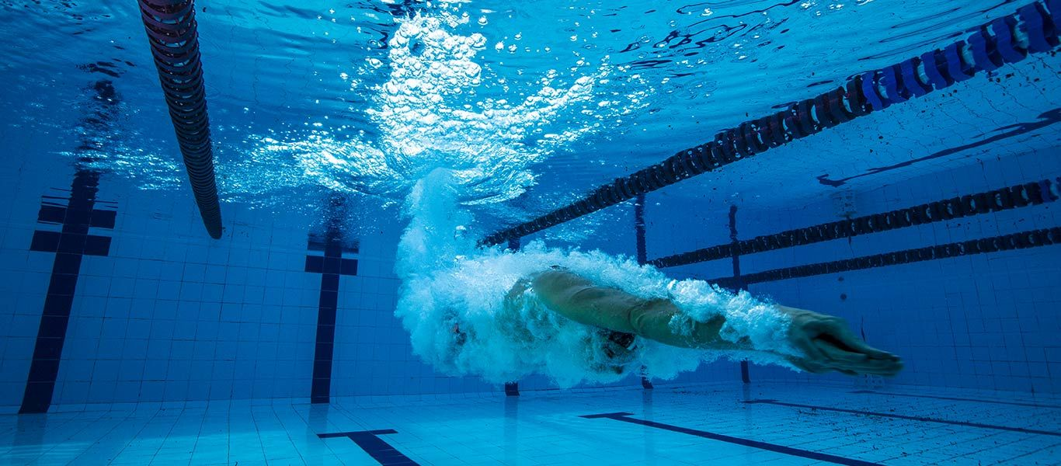
An athlete’s strengths and weaknesses will also begin to reveal themselves at this phase. It is crucial for both athletes and coaches to work together to recognize the areas where an individual swimmer is proficient, and where more focus and attention is required. Meanwhile, it will be equally important to nurture the athlete’s strengths, while not promoting over-confidence based on this knowledge. It is recommended to track an athlete’s progress in specific swimming skills, and to identify where he/she is strongest and weakest.

Physical and cognitive changes will occur quickly during this phase, and it is important for coaches and parents/caregivers to monitor these changes. After the onset of Peak Height Velocity (PHV), strength training should be emphasized (Females: immediately after PHV and with the onset of menarche / Males: 12-18 months after PHV). The focus of this strength training should be shoulder, elbow, core, spine and ankle stability. In addition, musculoskeletal evaluations should be included in athletic monitoring during PHV. Throughout these physical and cognitive changes, the balanced physical conditioning and flexibility taught during the previous phases should be continued.

As competitive participation will increase during this phase, it is important for coaches to closely observe an athlete’s individual racing skills and performance (if available, videos are extremely beneficial to review after the race!). This observation will allow both parties to work together when developing a swimmer’s individual race tactics and game plan. Furthermore, coaches should introduce specific goal-setting skills, as well as concentration, positive reinforcement, patience, self-control and mental coping skills for use during competitions. Imagery and relaxation skills are also beneficial when improving technique and self-confidence, and can allow an athlete to create a positive sense of his/her ability when entering competition or training (and can also help coaches to practice patience with their swimmers!).

Intermediate Stage

The following mental characteristics are inherent with personal growth at this stage of an individual’s development, and should be carefully considered, so to ensure that confidence, positive attitudes towards sport, proper mental preparation and respect are maintained:

Cognitive Development
Basic Characteristics  - Athletes develop a new form of egocentric thought. Much emphasis is placed on self- identity  - Athletes are eager to perfect skills. | Performance Capabilities  - Decision making through more complex technical training should be introduced  - Athletes have a strong fear of failure  - Individual and specific direction and structure in the learning process is required  - A variety of methods to measure success is important to maintain motivation.

Emotional Development
Basic Characteristics  - Athletes are influenced significantly by their peers  - Athletes can accept responsibility  - Athletes enjoy cooperation  - Tension exists between adults and children;  - Physical, mental, and emotional maturity do not necessarily develop at the same rate. | Performance Capabilities  - Values and attitudes continue to be created and reinforced by the team  - Some athletes may be less responsive due to a fear of failure  - Communication channels should be kept open by the adult because all teenagers need help although they often do not recognize the need for it  - Social activities are important events for this age group.

Similar to the preceding phases, it is vitally important for coaches to create a learning environment that promotes teamwork, integrity, positive decision-making and strong work ethic. Coaches (and parents!) must not play favourites, as each athlete deserves equal attention as they strive for greatness. Additionally, athletes require positive role models, and the coaches or parents become the obvious choice. These individuals must maintain their own sense of respect and a positive attitude, while exhibiting the proficient ability to demonstrate the various swimming skills.
Swimming for Facts

A coach is only as good as his/her students!

A coach that demonstrates dedication to the sport and its athletes will have a greater chance of receiving the same loyalty in return!

Intermediate Stage

To-do list for the Intermediate Stage: Phase II

Complete a mental skills self-assessment
Introduce goal setting skills (short and medium term)
Introduce skills of time management
Introduce athlete understanding of planning and Periodisation
Complete a performance plan for the season
Promote use of a training and performance diary/log
Further development of specific mental skills: tension control and technical cues, constructive self-talk, imagery and confident behavior
Introduce:
  - Basic pre-competition preparation and routine
  - In-competition focus planning
  - Performance monitoring (i.e., evaluating competitive performances)
Continue to develop concentration
Continue to promote positive reinforcement
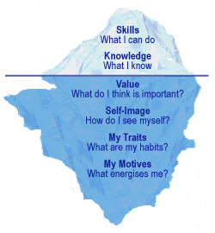
Teach patience and self-control as well as coping with winning and losing

Swimming for Facts

The iceberg theory refers to the
concept that only 10% of what
we do is observable by those
around us. The other 90%
consists of intrinsic factors
such as motivation, work-ethic
values, attitudes, etc.

Applied tothe BLTAD, coaches and athletes alike should consider the iceberg theory, and apply it to training, competition and daily life as they prepare for athletic success. By
considering this theory, coaches and athletes will gain a better understanding of their approach
to athletic and personal tasks, which will allow for the best practical application of their greatest traits, and ultimately contribute to stronger
observable characteristics (the 10%).

Advanced Stage “WHALE”
32

Male: Ages 15-18  Female: Ages 16-18  Schools: Secondary | Key Stakeholders:  Parents Coaches Ministry of Education BNSC BNOC BSSA BISA Sport Clubs Ministry of Youth, Sport & Culture
Key Considerations:
TRAIN TO COMPETE – Understand and apply the key elements of preparing for and participating in competition
Develop individualized skills and create a personal ‘style’
Develop the ability to compete at a high level and in multiple environments
Begin event-specific and rigorous physical conditioning
Maintain post-PHV strength and conditioning development with a consistent training program

Primary Objective:
Shift training focus from physical & mental development to the application of skills and strategies in competition.
Types of Training: Athlete-specific focus; volume and intensity should be based on specific events and periodization  Skills to Train:  Mastery of strokes, adaptation to competitive environments, adaptation to opponents, imagery skills, goal-setting skills  Types of Competition:  Competition should include multiple events below, at, and above the athlete’s level of competition. Focus should be on individualized competitive regimes including warm-up, cool-down, proper nutrition & hydration, recovery and mental preparation | Duration of Training:  90-120 minutes per session  Swimming Frequency:  8-12 sessions per week (16-24 pool hrs)  Non-Swimming Frequency:  Specialization to a particular performance sport should begin (swimmers to identify strokes with which they are prominent). Training activities should be balanced and may include other basic movement sports  See appendix G for a list of important responsibilities for the various stakeholders of the Advanced Stage

Advanced Stage
Readiness to advance determined by performance and mastery of competencies
Train to Compete

At this stage of the BLTAD, the focus should be on the mastery and individualization of training regimes and competition planning. The important swimming skills to develop at this stage are:

- Strokes (highly critical application of specific strokes)  - Further refinement of swimming skills from the Basic and Intermediate Stages | - Race starts  - In-water turns  - Pre and post-race training programs (nutrition, hydration, stretching, rest & recovery, imagery)

As athletes reach this stage, the will have developed a strong foundation of FUNdamental movement and swimming-specific skills. An important aspect to remember moving through the proceeding stages is that these skills are subject to regression. It is crucial for athletes to continue with a consistent training regime that not only prepares their body for specific events, but that also maintains the proper technical application of basic swimming skills. Without these skills, competitive performance will fade as a result of poor foundational elements including floatation, gliding and breathing.
Swimming for Facts

Competition training should become a specialized practice at this stage. Each athlete will have individual requirements, and it is crucial for coaches and swimmers to observe and recognize what works best, so to design and follow the best possible training regime.

In addition, tactics relating to mental preparation, racing strategies and the ability to assess and adapt to opponents should be refined at this stage.

In the previous stages, proper nutrition was emphasized for the purpose of physical and cognitive development. At this stage, nutrition and hydration are equally as important, but are now emphasized for competitive performance. It is not enough to simply prepare your body with specific skills training, but with proper fuel as well. Adequate water and nutrient intake during the days leading up to an event, on the day of the event, and throughout the days after the event are crucial to success for that day and in the future.

Advanced Stage

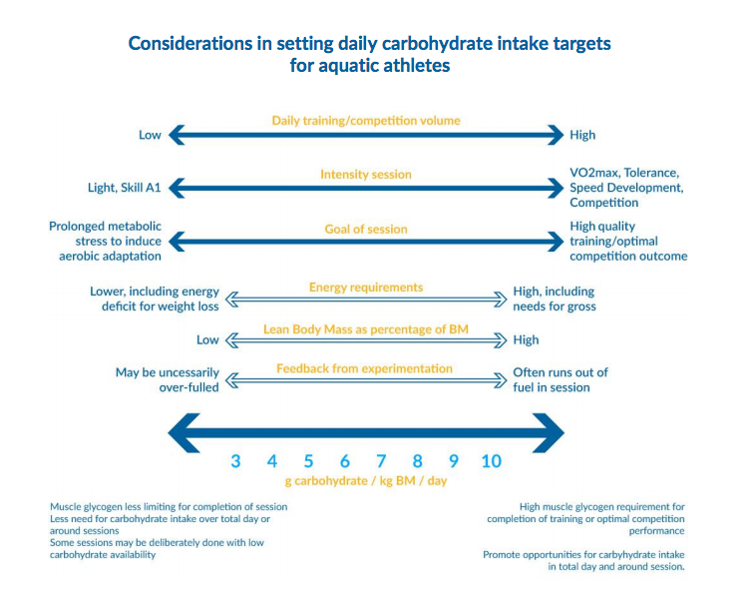
During training, and when preparing for a competition, carbohydrates can be a vital source of energy. FINA research has shown that a depletion of carbohydrate stores in the body can cause fatigue, and result in weaker training and event performance. This research also shows that carbohydrate intake during athletic training and performance must be individualized, much like the specific training regimes discussed throughout this framework. The exact carbohydrate intake, and the energy that the body’s muscles will need depends on the frequency, duration and intensity of training, and the athlete’s training and/or competition goals. These factors will cause the carbohydrate load to change daily, and require the intake to be tailored to fit with the body’s specific needs.

Similar to the early stages of athlete development, the body’s responses to variations in carbohydrate intake should be closely monitored by coaches, parents/caregivers and the athletes themselves, so to better understand individual needs. The table above, titled “Considerations in setting daily carbohydrate intake targets for aquatic athletes” was adapted from FINA’s “Nutrition for Aquatic Athletes” research, and outlines how intake may be tailored based on training goals and competition requirements.

Additionally, it is equally important to ensure that the body is properly hydrated when planning for and participating in competitive swimming. Water loss may occur for a multitude of reasons, including losses caused by training (sweat, respiration), hot temperatures, high altitude, and losses by normal daily living, among others.

Advanced Stage

The same FINA research identified above indicates that it is typically not necessary to replace fuel losses during exercise that occurs in less than a 40 minute period, however it is the athlete’s discretion as to whether or not their body will feel better drinking water during these sessions. When training or competition lasts more than 40 minutes, water intake will be helpful in replenishing the body’s lost fuel cells. The research indicates that water and carbohydrates are the body’s greatest source of energy required to participate in athletic training or competition.

During training or competition, a general rule of thumb identified by FINA is that an athlete should drink approximately 1.2-1.5 litres of fluid for each kilogram (kg) of weight lost. This should not be taken as a requirement for each athlete, as the individualized training and nutrition program should also consider the effect that water and carbohydrates will have on different bodies. For prolonged athletic exertion, typically any activity that will last longer than one hour, a rehydration plan should be initiated that considers the specific needs of the athlete’s body.

A link to the FINA document, which further identifies the importance and application of carbohydrate and fluid intake, can be found in the references section of this document.

The following mental characteristics are inherent with personal growth at this stage of an individual’s development, and should be carefully considered, so to ensure that confidence, positive attitudes towards sport, proper mental preparation and respect are maintained:

Cognitive Development
Basic Characteristics  - Generally by age 16, the brain has reached its maximum size but continues to mature neurologically for several more years  - Critical thinking is well developed during this phase | Performance Capabilities  - Athletes can cope with multiple strategies and tactics, particularly during the end of this phase  - The capacity of self-analysis, self-correction and correction by the coach are developing

Emotional Development
Basic Characteristics  - Peer group influence is still a powerful force  - Athletes are searching for a stable, balanced self-image  - Activities and interaction with the opposite sex are important during this phase and become a distracting influence | Performance Capabilities  - Independent decision-making and leadership skills are becoming more developed  - Self-concept is still very much influenced by success and failure, coping techniques are useful  - Male athletes must be aware that female athletes now face a problem of femininity versus sport development  - Female athletes must be aware that male athletes now face a problem of relating performance to masculinity

Advanced Stage

At this stage, athletes will begin to develop and master the skills required to be respectful and high-performing competitors. They have a responsibility to understand how personal health, environmental awareness, and rest and recovery will influence performance and injury prevention. The training and competition regimes developed through these recommendations will help grow an athlete’s ability to cope with competition. These athletes must also begin to understand how to manage socio-cultural characteristics such as media, public speaking, balancing sport and academics, among others. Athletes will also begin to develop their ability to lead. It is the responsibility of the coach and parents/caregivers to foster this leadership, and allow it to flourish in the proper environments, without overwhelming the individual.

To-do list for the Advanced Stage

Perform an assessment of individual behavioral strengths, weaknesses and motivations as related to competitive performances (a formal meeting with a sport psychology professional is appropriate for this task at this stage)
Identify potential in-competition distractions and create specific plans to manage each situation
Create specific plans to manage different environments e.g. heat/cold/rain/altitude where appropriate
Refine imagery skills (competition, different situations/problems, practicing the strategies)
Refine skills for anxiety control and relaxation (breathing, Progressive Muscle Relaxation, Hypnosis)
Refine focus and thought control – self talk/verbal cues (dealing with distractions and negative thoughts)
Refine goal setting skills (short, mid and long term)
Refine pre-competition preparation and in-competition game plans
Apply mental plans to practice sessions
Refine self-monitoring
Introduction to on-line performance monitoring for practice and competitive situations (if available)

432

Key Considerations:
COMPETE TO WIN – Compete at consistent high levels and in multiple environments
Develop natural/automatic competition-specific training skills

Compete successfully at national and international levels if possible
Create and direct personal training programs with support from coaches
Develop advanced physical, technical and tactical skills
Refine lifestyle to prepare for post-high performance career

Primary Objective:
Elite Stage
“SHARK”
Apply event-specific training programs to maintain and improve physical and mental capabilities, with a goal of maximizing performance over a long-term competitive schedule.
Types of Training: Volume and intensity should remain directed to specific events and periodization. Training programs should be individualized  Skills to Train:  Refinement of advanced strokes, adaptation to competitive environments, strategizing against opponents, decision-making skills, ability to evaluate and apply advice, ability to refocus wen necessary  Types of Competition:  Competition should include multiple events below, at, and above the athlete’s level of competition. Focus should be on developing and implementing effective event-specific competition strategies, modeling all performance aspects in training, and using strengths in races while exploiting weaknesses of opponents | Duration of Training:  90-150 minutes per session  Swimming Frequency:  10-15 sessions per week (20-24 pool hrs)  Non-Swimming Frequency:  Specialization to athlete’s particular performance sport (specific strokes/races). Training activities should be balanced and may include other basic movement sports  See appendix H for a list of important responsibilities for the various stakeholders of the Elite Stage

Elite Stage
Compete to Win

At this stage of the BLTAD, the focus should be on the development of advanced competitive schedules and event-specific training regimes that promote optimal performance at specific times. The important swimming skills to develop at this stage are:

- Strokes (highly critical application of advanced strokes)  - Further refinement of swimming skills from the Basic, Intermediate and Advanced Stages  - Refinement of racing tactics | - Race starts  - In-water turns  - Advanced pre and post-race training programs (nutrition, hydration, stretching, rest & recovery, imagery)

By the elite stage, athletes should have an understanding of their skills and potential, and will develop a desire to compete and win. It is important to foster and help to fuel this competitive drive, however, similar to the advanced stage, athletes are subject to regression if their long-term development is not approached properly. As mentioned in the Specialization section of this framework (found on page 9), athletes may not reach their maximum performance until they are into their 20’s, which means that their careful progression at this stage is equally as important as it was during the basic stage.
Swimming for Facts

Competition training should become second nature at this point. Athletes and, to a degree, their team, should have an advanced understanding of the training and competition strategies that work best to foster high-level performance. These strategies should be exploited to allow for optimal competitive performance on the day of an event.

Much of the athlete’s life at this stage will be dedicated to training and competitive performance. The individual should take control of his/her daily regimen, and include a focus on advanced nutrition techniques for practice and competition, as well as a fully refined and personalized training program. The athlete should also begin to select those coaches and advisors that he/she views as core members of the team, while looking to compete at the national and international levels. The tactics employed during events should include adaptability to the environment and competition, as well as the ability to improvise using the foundation of skills developed throughout the athletic career.

In addition to the advanced physical development of the athlete, swimmers at this stage should understand and be able to effectively use their mental, cognitive and emotional strengths to their advantage during training and in competition. This includes the ability to cope with stress, and refocus after inevitable setbacks, obstacles or failures occur. While the development of a successful team is important, it is also crucial that the athlete is able to evaluate and decipher good advice from that which is impractical for their specific training regime. This goes hand-in-hand with the development of decision-making skills during competitive events and for the athlete’s lifestyle.

Elite Stage

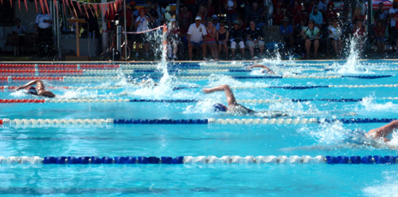
At this stage, swimmers should be recognized as leaders in their community and in the pool. Respect for their competitors, coaches and other members of the swimming population should be a priority, in addition to positive reinforcement and a strong work ethic, which will help with the development of younger athletes that aspire to reach the Elite Stage.

The following mental characteristics are inherent with personal growth at this stage of an individual’s development, and should be carefully considered, so to ensure that confidence, positive attitudes towards sport, proper mental preparation and respect are maintained:

Cognitive Development
Basic Characteristics  - Neurologically the brain matures when athletes are between 19 and 20 years of age  - There is significant understanding and acceptance of the need for rules, regulations and structure. | Performance Capabilities  - Athletes are capable of self-analysis and can correct and refine skills themselves  - Athletes can analyze and conceptualize virtually all facets of their sport  - Well developed information processing skills help to improve the athlete’s ability to visualize verbal instructions  - For the young adult, the rules and structure of training and competition must be perceived as clearly defined and fair.
Elite Stage

Emotional Development
Basic Characteristics  - There is a need to be self-directed and independent  - Self-actualization and self-expression are important  - Major decisions about career, education and lifestyles become a priority during this phase  - Interaction with the opposite sex continues to be a priority and lasting relationships develop. | Performance Capabilities  - The athletes are ready to assume responsibility and to accept the consequences of their actions  - Major changes in interest, hobbies and physical activities may occur during this phase.

This stage incorporates a continual pursuit of performance excellence, as well as a strong passion for sport and physical activity, which will prove to be essential as athletes aspire to reach the national and world-class levels. Characteristics including, but not limited to, concentration, responsibility, discipline, accountability, leadership, problem-solving and a competitive mentality will be vital to the athlete’s development at this stage, while coaches and parents/caregivers should allow athletes to enter into environments that foster these traits. At this stage, high-level performance should be a major objective, but overall athletic development should not be sacrificed.

Finally, swimmers at this stage should be provided with access to professional guidance, allowing them to make appropriate decisions about off-season and educational planning. Lifestyle decisions should be given more consideration at this stage, as athletes must develop a comprehensive and integrated sport, career and life plan.

To-do list for the Elite Stage

Consolidate well-developed, refined and individualized mental skills and routines
Promote refocusing plans/coping strategies
Promote the will to win and drive for competition
Consolidate the ability to concentrate and refocus
Establish regular use of practice and game plans
Develop coach interaction plans where appropriate
Promote independent decision-making
Develop athlete’s capacity to work in a team environment and evaluate advice from outside sources
Cultivate a total focus on sport performance when in competitive season
Use on-line performance monitoring for all competitions where available and appropriate to determine if improvements are occurring

5432
“FINS FOR LIFE”

Lifelong Physical Activity

No Age Restriction  Schools: Tertiary Institutions of Higher Learning | Key Stakeholders:  Parents Coaches Sport Clubs Ministry of Youth, Sport & Culture Armed Forces BOTESA BNSC BNOC BSSA Ministry of Youth, Sport & Culture Armed Forces
Key Considerations:
ACTIVE FOR LIFE – Refine lifestyle to meet future athletic goals
Implement plan for active lifestyle (if this is the athlete’s chosen path)
Athletes should conduct internal review to determine level of commitment, in addition to physical and mental status
Athletes should consider complimentary activities to continue physical/competitive activity

Primary Objective:
Begin the process of adjusting the body to a lifestyle outside of competitive sport. Set and begin to implement a plan for the future (second career sport or active lifestyle), allowing athletes to meet various goals.

Types of Training:  Second Career Sport Specialization to second sport focus  Active Lifestyle Plan Focus on non-specialized active living  Training should be activity-dependent, training should begin at 60-80% of current training level and can increase or decrease gradually (for second career or active lifestyle, respectively) | Types of Competition:  Dependent on the athlete’s chosen future plan. Recommendation is to engage in recreational competitive activities  Duration of Training, Skills to Train:  Dependent on the athlete’s chosen future plan  Swimming Frequency:  Recreational competition or leisurely activity  See appendix I for a list of important responsibilities for the various stakeholders of the Lifelong Physical Activity Stage

Lifelong Physical Activity Active for Life

At this stage of the BLTAD, the focus should be on preparing the body for a second sporting career, or for an adjusted lifestyle that incorporates recreational athletic participation. The important athletic skills to develop at this stage are:

- Endurance  - Strength  - Flexibility | - Sport administration  - Coaching  - Recreational retention of FUNdamental sport skills learned throughout the BLTAD

This stage should be viewed as a parallel option to the Intermediate, Advanced or Elite stages, as opposed to the linear progression after the previous sections of the BLTAD have been completed. It is not an end stage, but rather one that athletes can enter at any point during their life, while also affording the opportunity to re-enter other stages in the same or new sports.

The concept of Lifelong Physical Activity should be understood for its literal meaning: it involves life-long participation and the ability to enjoy sport and/or physical activity regardless of skill level or athletic retirement from a previous sport. The primary goal of this stage is to allow participants to recognize the value in remaining physically active throughout their youth and adult lives. In order to accomplish this goal, government and sport organizations should play a crucial role, as they must encourage and provide outlets for individuals to remain involved in sport as a participant, coach or official. In addition, all stakeholders should provide encouragement to try new sports and lifestyle activities that are different than those encountered in other BLTAD stages.
Swimming for Facts

The key to long-term retention in sport and sports clubs is not whether or not a person has innate high level physical or mental sport skills, but the fact that they have had a positive, fun and safe experience in sport.

Lifelong Physical Activity

Similar to previous stages, self-reflection and an individualized focus to activity schedules will need to be determined by the athlete. As motivational factors and physical activity requirements will differ from person to person, it will be important for each member of this stage to properly understand their specific needs and goals. The athlete’s lifestyle goals will also change, which opens up other opportunities for education and/or career development, and a greater pursuit of personal and family goals, among others. Additionally, a restructured focus towards coaching, sport administration or media should be encouraged, as these will carry vital responsibilities to the continued excellence of new athletes in Botswana.

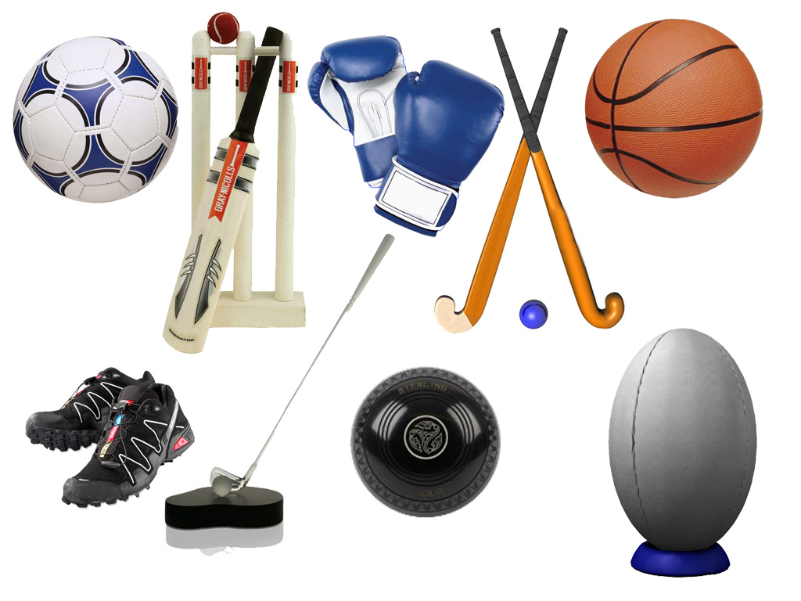
Finally, the adjustment to a post-high performance sport career may be a difficult endeavor. Athletes are encouraged to seek aid and support with this transition.
Swimming for Facts

Lifelong nutritional participation should also be considered at this stage. Regardless of age or gender, proper nutrition is one of the most important elements to consider when striving for complete physical and cognitive development.

Athletes With A Disability (AWD)
Integration into the BLTAD should be accessible for all athletes, and the following section will identify the methods to be used to accomplish the integration of Athletes With A Disability (AWD) into each stage of this framework. While there may be obvious differences when working with AWD, the attitudes towards sport and physical activity, as well as the foundational components of development, growth and training exhibited by these athletes will allow them to participate amongst their peers. Coaches, parents, and other stakeholders should remain mindful of physical and mobility differences with AWD, and must allow for free access to all required training facilities. The same general considerations will exist for AWD at each BLTAD stage in regards to physical progression and mental considerations. Just as coaches would adapt their strategy and methods to meet the size, skill and motor ability differences between non-disabled athletes, the same considerations must be given for AWD.

Considerations for AWD for the Botswana LTAD Stages in each stage are as follows:

Basic Stage (Minnow)  There does not need to be special allowances for AWD. The primary focus of this stage is fun, enjoyment and allowing children to explore and develop their basic motor skill patterns, This should be no different for AWD, although obviously there will be some skills and movement patterns that AWD will not be able to do depending on their disability. AWD should be encouraged to stretch the scope and limits of their own movement and implement handling skills in the air, on the ground and in the water in the same manner as a non-disabled athlete. | Intermediate Stage (Otter)  Phase 1  AWD should continue to develop their motor skills, continue to engage in unstructured play and learn the basic foundations of good training and recovery principles. – in the same manner as non-disabled athletes (but obviously necessarily the exact same skill level) They should follow the same principles of training : competition ratios as laid out in the section on Intermediate Stage.  Phase 2  AWD should be introduced to sport specific equipment that is used for their sport(s) and their disability.
Advanced Stage (Whale)  AWD should follow the same principles and guidelines of training, training: competition ratios, Periodisation and preparation for competition and review of competition as non-disabled athletes.  AWD should be introduced to International Paralympic Committee rules and guidelines for competition and classification procedures. | Elite Stage (Shark)  AWD should follow the same guidelines as non-disabled athletes in terms of preparing for high-level competition with a focus towards optimal performance. AWD need to optimize specialized equipment necessary for their sport and disability.
Life-Long Physical Activity (Fins For Life)
AWD are encouraged to maintain healthy lifestyles either through participation in physical activities for recreational purposes or as coaches and/or officials.
Athlete Retirement

Similar to any activity or practice that has become routine in an individual’s life, the removal of sport participation can be difficult to overcome for many athletes. It is for this reason that support systems should be put in place to help guide an athlete through this process of transition to a life beyond sport. Coaches, parents/caregivers, national federations and the various sport organizations must play a crucial role in this transition. These key stakeholders will have a great influence on the athlete’s life, and should help to provide an environment that is filled with alternative options to occupy the individual’s new lifestyle. Often, athletes have enjoyed very busy schedules with competition, training, education and work, among other items. This sudden loss of sport, and a significant amount of their schedule may create an overwhelming feeling for some athletes. Sport psychologists should also be made available to help mentally guide an athlete through this process.

While post-retirement aid is important, preparation for this transition is equally as important. Sport organizations can help ease this process for soon-to-be retired athletes by providing opportunities to continue engaging in sport from an administration or coaching perspective. Finally, a support system and retirement plan should be in place prior to the athlete’s removal from the sport (unless the retirement is unexpected).

Involuntary Loss of Sport

While the ideal end to an athlete’s sporting career will be a voluntary action, situations may occur where athletes will be forced to remove sport from their current lifestyle, and adapt to a new one involuntarily. This obligatory elimination of sport may be caused by injury, geographic displacement, and work obligations, among others.

When these scenarios emerge, it is important to encourage athletes to consider the priorities in their current and future lifestyles before deciding whether to risk long-term goals for short-term gains. Many difficult scenarios will include a severe injury, after which the athlete must assess whether the risk of re-injury is worth continuing with a career in that particular sport. Scenarios including mild traumatic brain injuries (mTBI or concussion), back and spinal injuries, or musculoskeletal injuries (especially in young and growing athletes) must be met with great caution, as improper care may result in a more severe injury later in life.

The BNSC, BNOC, BSSA and local sport organizations must be diligent in their approach to injuries and other instances of an involuntary removal of sport, and should provide many of the same support options as noted above under athlete retirement.

Collaboration

Just as any championship team requires the commitment and collaboration of
its players, coaches, trainers, management and owners, a successfully implemented BLTAD requires a complete alliance between athletes, coaches, parents/caregivers, teachers, sport clubs, national federations, government organizations and other key stakeholders.

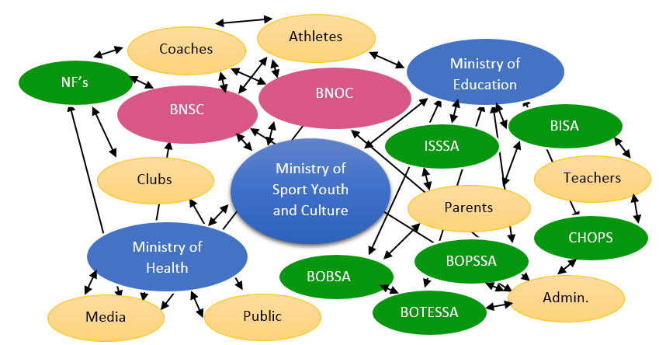
Some stakeholders may provide a more immediate impact on athlete development, such as a coach or trainer, however each member of this alliance has unique responsibilities that are pertinent to the successful implementation of this framework. If each member’s focus is directed towards a common goal, the means to accomplish the objectives will become much easier, and will result in rewards for everyone involved.

At times, members of this alliance may feel temptation from an outside organization or stakeholder to pursue athletic results above development. Additionally, an institution may promote BLTAD, yet reward only results, neglecting the most important elements of this framework. It is crucial for all stakeholders to remain committed to the same goal, ultimately allowing coaches to emphasize and foster athletic development before results. Coaches should receive the highest recognition for the proper development and consistent production of young athletes in Botswana, while acknowledging when their athletes accomplish feats of excellence in competition as a secondary element of this process.
Swimming for Facts

Role of Governing Bodies in the BLTAD Alliance:

- Provide education to stakeholders on ground and at the top
- Implement age-appropriate program structure
- Implement age-appropriate competition structure
- Develop a national structure that provides a clear pathway of progression from grassroots to podium and beyond
- Appropriate and standardized talent identification and selection
- Align polices and age-appropriate funding/recognition
- Stakeholder alignment
- Send a consistent message

BLTAD Committee

While this framework will act as a guide to help clubs in Botswana to direct their swimmers through the process of athlete development, a method is required to ensure that the BLTAD for swimming is being implemented effectively. For this reason, and to provide a group with advanced knowledge of LTAD, it is recommended that a BLTAD committee be created by the BSSA to oversee the implementation of this framework. This committee will also be responsible for updating key stakeholders on the progress of LTAD for swimming, while also conducting any surveys or inquiries necessary to ensure the continuous progression of swimming in Botswana.

The committee should consist of at least one representative each from the BSSA and BNOC, coaches from clubs in Botswana, as well as any stakeholder representatives deemed essential by the BSSA.
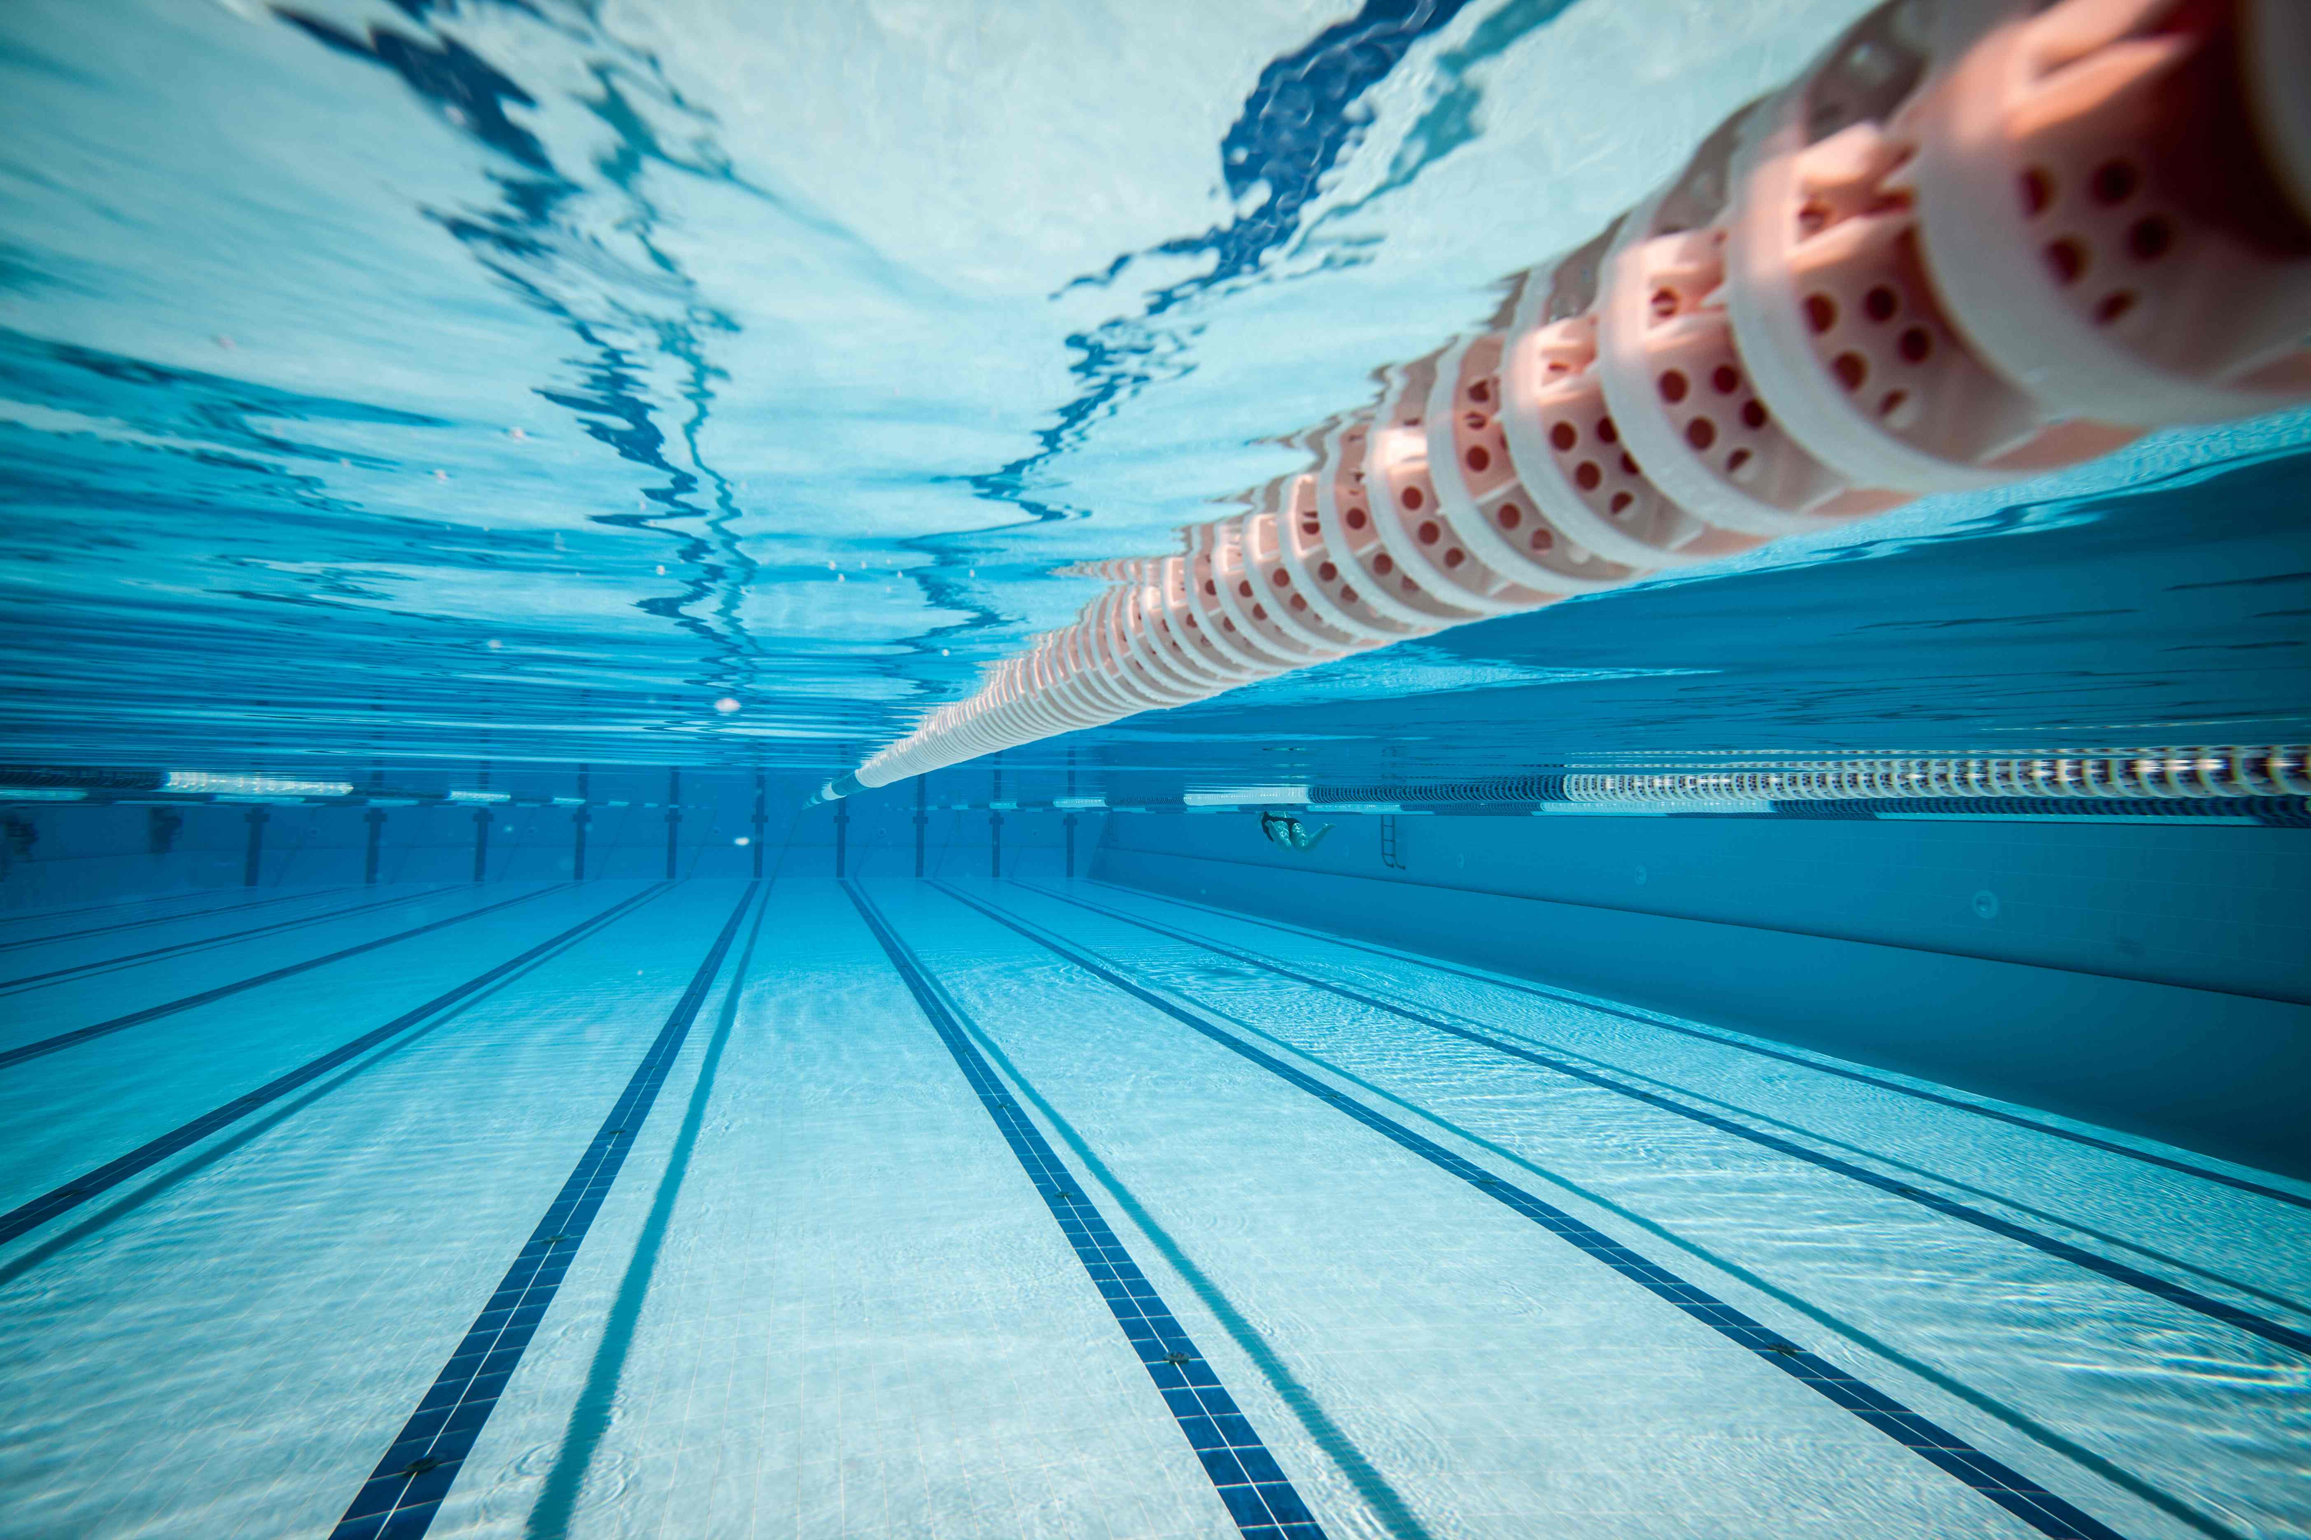
Appendices

Examples of FUNdamental Movement Skills
Locomotion Skills | Object Control Skillls | Balance Skills
Running (forward & backward)  Jumping  Hopping (one foot, two foot)  Skiping  Crawling  Crab Walking  Leaping  Climbing  Galloping  Bounding  Swinging  Wheeling  Log roll | Kicking  Punching  Rolling (ball)  Sticking object (moving)  Striking Object (stationary)  Throwing  Catching  Stopping/Trapping  Dribbling (with feet)  Dribbling (with hands)  Blocking  Aiming  Two hand strike (bat) | Balancing/Centering  Rolling (somersault)  Dodging  Floating  Landing  Squatting-balancing  Sinking (in water)  Falling (through Air)  Spinning  Stopping  Stretching  Swinging  Twisitng  Standing on hands and head
Appendix A

Appendix B

BASIC STAGE | INTERMEDIATE STAGE | ADVANCED STAGE | ELITE STAGE
 | Phase I Phase II | Progression through both stages
No specific ratios. Competition should be very low to low intensity both physically and mentally, e.g. using modified rules; and no League or overall city, regional or national championships | No more than 70% of total time in General and Preparatory Training to 30% of total time in Competition simulation or direct Competition specific Training in Phase I (70:30)  No more than 60% of total time in General and Preparatory Training to 40% of total time in Competition simulation or direct Competition specific Training in Phase II (60:40) | No more than 40% of  total time in General and Preparatory Training to 60% of total time in Competition simulation or direct Competition specific Training at (40:60) | No more than 25% of total time in General and Preparatory Training to 75% of total time in Competition simulation or direct Competition specific Training in Elite Stage. (25:75)
No national championships | No national Championships  until at least Phase II (12-16 years for Males, 11-15 for Females) | Regional, National and International  Championships for both Stages

Appendix C

Swimmer’s Name  (Age) | DATE | DATE | DATE | DATE | DATE | DATE
 | Attnd:  Start Lvl:  End Lvl: | Attnd:  Start Lvl:  End Lvl: | Attnd:  Start Lvl:  End Lvl: | Attnd:  Start Lvl:  End Lvl: | Attnd:  Start Lvl:  End Lvl: | Attnd:  Start Lvl:  End Lvl:
 | Attnd:  Start Lvl:  End Lvl: | Attnd:  Start Lvl:  End Lvl: | Attnd:  Start Lvl:  End Lvl: | Attnd:  Start Lvl:  End Lvl: | Attnd:  Start Lvl:  End Lvl: | Attnd:  Start Lvl:  End Lvl:
 | Attnd:  Start Lvl:  End Lvl: | Attnd:  Start Lvl:  End Lvl: | Attnd:  Start Lvl:  End Lvl: | Attnd:  Start Lvl:  End Lvl: | Attnd:  Start Lvl:  End Lvl: | Attnd:  Start Lvl:  End Lvl:
 | Attnd:  Start Lvl:  End Lvl: | Attnd:  Start Lvl:  End Lvl: | Attnd:  Start Lvl:  End Lvl: | Attnd:  Start Lvl:  End Lvl: | Attnd:  Start Lvl:  End Lvl: | Attnd:  Start Lvl:  End Lvl:
 | Attnd:  Start Lvl:  End Lvl: | Attnd:  Start Lvl:  End Lvl: | Attnd:  Start Lvl:  End Lvl: | Attnd:  Start Lvl:  End Lvl: | Attnd:  Start Lvl:  End Lvl: | Attnd:  Start Lvl:  End Lvl:
 | Attnd:  Start Lvl:  End Lvl: | Attnd:  Start Lvl:  End Lvl: | Attnd:  Start Lvl:  End Lvl: | Attnd:  Start Lvl:  End Lvl: | Attnd:  Start Lvl:  End Lvl: | Attnd:  Start Lvl:  End Lvl:
 | Attnd:  Start Lvl:  End Lvl: | Attnd:  Start Lvl:  End Lvl: | Attnd:  Start Lvl:  End Lvl: | Attnd:  Start Lvl:  End Lvl: | Attnd:  Start Lvl:  End Lvl: | Attnd:  Start Lvl:  End Lvl:

Appendix D

Level 1: Tadpole  Level 1 Requirements: | Water mobility confidence  The athlete must demonstrate consistent proficiency in moving about the pool with confidence, as well as the ability to safely enter and exit the pool without issue.
Level 2: Goldfish  Level 2 Requirements: | Water submersion confidence  The athlete must demonstrate consistent proficiency in submerging the entire body in water, including head, while also competently recovering from submersion.
Level 3: Starfish  Level 3 Requirements: | Underwater breathing & buoyancy competence  The athlete must demonstrate the consistent ability to safely hold his/her breath underwater for five (5) seconds, with a safe and competent recovery.  Additionally, the athlete must demonstrate the ability to hold a technical front float (starfish/T float) and back float (reverse).
Level 4: Frog  Level 4 Requirements: | Competent technical glide (aided)  The athlete must demonstrate the consistent ability to glide across the length of the pool with technically sound body position, while using either a floating board or instructor as an aid.
Level 5: Turtle  Level 5 Requirements: | Competent technical glide (unaided)  The athlete must demonstrate the consistent ability to glide across the width of the pool with technically sound body position, without the use of any swimming aids.
Level 6: Penguin  Level 6 Requirements: | Competent swimming strokes (aided)  The athlete must demonstrate the consistent ability to employ technically sound arm strokes and kicking to swim across the length of the pool, while using either a floating board or instructor as an aid.
Level 7: Dolphin  Level 7 Requirements: | Competent swimming strokes (unaided)  The athlete must demonstrate the consistent ability to employ technically sound arm strokes and kicking to swim across the width of the pool, without the use of any swimming aids.

Appendix E

Checklist for Implementation of the Basic Stage
Parents, Family | School, Child-Caregivers | Sport Organizations
- Provide opportunities for infants at the earliest possible age to move and balance in 3 dimensions  - Provide an opportunity for infants to move over different terrains with and without shoes everyday  - Provide opportunity for child to freely explore their physical space and physical abilities every day  - Provide at least 30-60 minutes per day where the child is free to move, balance and climb (with safe supervision)  - Provide an opportunity for children to invent their own games and rules  - Begin an awareness of proper eating behaviours and healthy food choices | - Ensure that Teacher/ Coaches are aware of Botswana LTAD (and other models)  - Ensure that children get at least 30-60 minutes of free play time per day (before, during and after school)  - Ensure that children receive at least 2 periods of structured physical activity per week where all physical literacy skills are taught, practiced and tested  - Provide access to school facilities for pre-school community children to play and use appropriate equipment outside of regular school hours  - Ensure that Teacher/ Coaches are aware of Botswana LTAD (and other models)  - Ensure that children get at least 30-60 minutes of free play time per day (before, during and after school)  - Ensure that children receive at least 2 periods of structured physical activity per week where all physical literacy skills are taught, practiced and tested  - Provide access to school facilities for pre-school community children to play and use appropriate equipment outside of regular school hours  - Ensure that games in early Primary years (years 6-9 Males, 6-8 years Females) are non- competitive and non-pressured  - Provide an opportunity for children to invent their own games and rules  - Do not allow children to be totally sedentary in schools for periods longer than 60 minutes | - Encourage young children to try your sport in a safe and non- competitive environment  - Encourage children in your sport to try other sports as well as your own.  - Ensure that coaches know the Stages of LTAD as well as the basic science and theory behind  - Ensure that coaches teach basic physical literacy (separately) and in game situations before starting on sport specific skills and before playing full games  - As children progress to final 2 or 3 years of Basic stage begin to develop full mastery of basic physical skills by execution at higher speeds and/or for longer periods, and in sport skill situations  - Ensure that children can move forward, backward and sideways and can hop and balance on 1 and 2 legs, and can throw, catch and kick small and large balls.  - Begin to introduce children to the rules of some games and the ethics and concepts of team play and teamwork (in the latter years of the BASIC stage)  - Make allowances for children who are progressing faster or slower than most of the group, but do not allow children to move up to INTERMEDIATE Stage until after 9 years (Males) or 8 (Females)

Appendix F
Checklist for Implementation of the Intermediate Stage
Parents, Family | School, Child-Caregivers | Sport Organizations
- Ensure that children are still encouraged to learn basic motor skills and basic sport skills  - Ensure that children are encouraged to try multiple sports in different seasons (and discouraged from specializing in 1 single sport)  - Resist the urge to pressure children to train and/or compete at too high a level  - Follow the guidelines of sport organizations for maximum time and intensity for training and/or competition (in Phase 1)  - Continue to encourage unstructured play which challenges and develops motor skills (e.g. running, climbing, kicking, throwing, swimming etc.) - Monitor nutrition knowledge, food choices and eating behaviours to avoid eating disorders, especially in female family members  - Become aware of onset of menarche and any irregularities and problems that may or may not be related to sport and/or sport related eating behaviours  - Monitor Training to Competition ratios (Phase 1 recommended no more than 70% : 30% Training to Competition and Phase 2 no more than 60% : 40%) | - Ensure that Teacher/ Coaches are aware of Botswana LTAD (and other models)  - Ensure that school curricula and school sport team training encourages mastery of basic physical literacy skills as well as combination of skills in faster and longer duration sets  - Ensure that school Physical Education and Health curricula includes content on healthy eating, eating disorders and Female Athlete Triad  - Incorporate strengthening exercises with body weight activities in Phase 1, progressing to more advanced strength training activities in Phase 2  - Encourage participation in 2-3 sports in Phase 1 and 1-2 sports in Phase 2  - Ensure that school sport coaches consider outside school sport activities when calculating appropriate ratios of Training: Competition (70% Training : 30% Competition & Competition related activities in Phase 1 and 60% : 40% in Phase 2  - Coordinate with outside school sports activity to ensure a Periodised program with 1 peaking phase in Phase 1 and 1-2 peaking phases in Phase 2 (depending on specific needs of the sport) | - Ensure that Coaches are well aware of Botswana LTAD (and other models)  - Continue to develop and incorporate physical literacy skills into training and skill development  - Begin to develop basic strength, agility and coordination training in Phase 1 and progress to more advanced development (i.e. at higher speed, and stronger intensity) in Phase 2.  - Coordinate with school sport coaches to ensure appropriate ratios of Training: Competition (70% Training : 30% Competition & Competition related activities in Phase 1 and 60%:40% in Phase 2  - Coordinate with school sports to ensure a Periodised program with 1 peaking phase in Phase 1 and 1-2 peaking phases in Phase 2 (depending on needs of your sport)  - Encourage participation in 2-3 sports in Phase 1 and 1-2 sports in Phase 2  - Build base of aerobic, speed,  strength and flexibility capabilities (in Phase 2) to provide foundation to enter Advanced and Elite Stages later  - Ensure that coaches are aware of issues related to eating disorders, and body image (especially in sports where body shape, weight and image is a significant factor in performance and success such as Gymnastics, Diving, Synchronized Swimming and sport with weight categories  - Increase focus on flexibility during phase of rapid growth in Phase 2  - Begin to prepare for specific competition through development of competition strategies and simple post- competition de-briefs in Phase 2  - Encourage children and adolescents to continue an active lifestyle in sports (not necessarily your sport) if they choose not to continue with an Advanced or Elite focus in next stages

Appendix G
Checklist for Implementation of the Advanced Stage
Parents, Family | School, Child-Caregivers | Sport Organizations
- Support adolescents in their endeavours to improve and compete  - Support adolescents who decide to be less competitive during or after this Stage and to transition to the Active For Life Stage if they choose that option. | - Ensure that Teacher/ Coaches are aware of Botswana LTAD (and other models)  - Coordinate with outside school sport organization(s) and coach(es) to ensure that appropriate Periodisation models are aligned (e.g. double and/or multiple peaks)  - Support decisions of participants to focus on 1 primary sport (if they choose that option)  - Teach and encourage participants how to prepare strategies and tactics for competition  - Teach and encourage participants to de-brief competition and build new strategies and tactics  - Encourage appropriate balance of training to competition (40% General Training : 60% Competition or direct competition related preparation)  - Ensure that coaches are aware of safe nutrition practices (eating and hydration) and that they are aware of and sensitive to the potential of eating disorders, especially in female athletes  - Encourage simulation or modeling of competition events in training and/or training games  - Support children who decide to be less competitive during or after this Stage and to transition to the Active For Life Stage | - Ensure that Coaches are well aware of Botswana LTAD (and other models)  - Provide year round high intensity training for desired event and position  - Ensure that training activities mirror necessary skills and skill combinations at intensities and durations required during competition  - Ensure that coaches are aware of safe nutrition practices (eating and hydration) and that they are aware of and sensitive to the potential of eating disorders, especially in female athletes  - Ensure that programs are Periodised with appropriate balance of training, recovery and competition (40% General Training : 60% Competition or direct competition related preparation  - Build Periodised plan and peaking periods to allow for multiple peaks if necessary according to the seasonal needs of your sport (and coordinated with Secondary School sport program  - Support decisions of participants to focus on 1 primary sport (if they choose that option)  - Ensure simulation or modeling of competition events in training and/or training games  - Support children who decide to be less competitive during or after this Stage and to transition to the Active For Life Stage

Appendix H

Checklist for Implementation of the Elite Stage
Parents, Family | School, Child-Caregivers | Sport Organizations
- Support adolescents in their endeavours to improve and compete  - Support adolescents who decide to be less competitive during or after this Stage and to transition to the Active For Life Stage | - Support and assist athletes to balance school AND sport objectives  - Provide training and competition activities at a high level | - Ensure a high level of training and recovery to allow for optimal competition readiness and performance  - Ensure that Periodised plan(s) have appropriate levels of high intensity training and appropriate recovery sessions  - Ensure a correct balance between training and competition and direct competition related activities. (Recommended up to 25% : 75% ratio)  - Allow single and multiple peaks as necessary for the specific seasonal needs  - Teach and practice high level opponent analysis, strategy and tactical development and post-competition de-brief  - Support adolescents who decide to be less competitive during or after this Stage and to transition to the Lifelong Physical Activity Stage

Appendix I

Checklist for Implementation of the Lifelong Physical Activity Stage
Parents, Family | School, Child-Caregivers | Sport Organizations
- Reinforcement from the earliest years that sport and physical activity is a family activity  - Participation in sport and lifestyle physical activities as a family  - Support of family members throughout each LTAD Stage and support of transition into (and out of ) Active for Life Stage | - Education and reinforcement that participation in sport and or physical activity has other benefits and outcomes beyond serious competition and winning  - Recognition that some participants in sport and physical activity do not have innate high performance abilities and do not enjoy or profit from highly competitive situations  - Facilitation of participants to engage in non-competitive, lifestyle activities, by providing a range of options for students | - Encourage and promote life-long physical activity and fitness as a  valuable personal lifestyle choice  - Provide events and opportunities for all Batswana to remain in sport after Advanced and Elite Stages as non- competitive adult participants, coaches and/or officials  - (Sport Organizations) ensure that all LTAD Stages (but especially Basic Stage) are enjoyable and non-pressured so that participants learn critical basic skills and have fun  - (Government Agencies) ensure that Sporting organizations are encouraged to provide Active for Life related activities for all Batswana

Appendix J

Learn To Swim Skills
- Kicking  - Water mobility (water confidence)  - Breathing techniques  - Blowing bubbles  - Full body submersion | - Front floatation (T-shape body position – arms outstretched, legs straight & together)  - Back floatation (Reverse T-shape body position)  - Front glide  - Back glide

Competitive Swimming Strokes (From FINA)
- Freestyle  - Backstroke | - Breaststroke  - Butterfly

References

American Red Cross. (2016). Swim Safety. Retrieved from http://www.redcross.org/prepare/disaster/water-safety/swim-safety
Balyi, I., Way, R., Norris, S., Cardinal, C., Higgs, C., & Smith, D. (2005). Long-Term Athlete Development 101. Retrieved from http://www.coach.ca/sportleadershipsportif/2005/e/presentations/documents/SLS05_LTAD_B2.pdf
Botswana National Olympic Committee. (n.d.). The Botswana Long Term Athlete Development Framework [PDF File].
Botswana Swimming Sports Association. (n.d.). Botswana Swimming Sports Association (BSSA) 2028 Strategy [PDF File].
Canadian Sport For Life. (2014). Long-Term Athlete Development 2.0. Retrieved from http://canadiansportforlife.ca/sites/default/files/user_files/files/CS4L%202_0%20EN_Jan17_web%20FINAL.pdf
Canadian Sport For Life. (2016). More About LTAD. Retrieved from http://canadiansportforlife.ca/learn-about-canadian-sport-life/more-about-ltad
Federation Internationale De Natation. (n.d.). Nutrition For Aquatic Athletes. Retrieved from https://www.fina.org/sites/default/files/nutrition_for_aquatic_athletes_booklet_v5_final.pdf
Federation Internationale De Natation. (2016). Rules and Regulation. Retrieved from http://www.fina.org/content/rules-and-regulation
Federation Internationale De Natation. (2016). Swimming For All – Swimming For Life. Retrieved from http://www.fina.org/content/swimming-all-%E2%80%93-swimming-life
Gordon, R. (n.d.). A Shorter Guide to Long Term Athlete Development (LTAD). Retrieved from http://www.swimming.org/assets/uploads/library/ASA_A_Shorter_Guide_To_LTAD.pdf
Lang, M., & Light, R. (n.d.). Interpreting and Implementing the Long Term Athlete Development Model: English Swimming Coaches’ Views on the (Swimming) LTAD in Practice. Retrieved from http://eprints.leedsbeckett.ac.uk/913/1/Interpreting_and_Implementing_the_Long_Term_Athlete_Development_Model1.pdf
Lloyd, R. S., & Oliver, J. L. (2014). Strength And Conditioning For Young Athletes: Science And Application. Retrieved from https://books.google.co.bw/books?hl=en&lr=&id=rXIdAAAAQBAJ&oi=fnd&pg=PA185&dq=ltad+nutrition&ots=kP13Axr4DV&sig=robWa4NJ39loXalVgyAEvdnkwSU&redir_esc=y#v=onepage&q=ltad%20nutrition&f=false
Raleigh, V. (2011). Long Term Development In Swimming. Retrieved from http://sal-live.aptsolutions.net/visageimages/1_SAL/Swimmers__Parents/Long_term_development_in_Swimming.pdf
Swim B.C. (n.d.). Canadian Sport For Life. Retrieved from http://canadiansportforlife.ca/sites/default/files/resources/Swim%20BC%20and%20Canadian%20Sport%20for%20Life.pdf
References

Swimming Canada. (2016). Long Term Athlete Development. Retrieved from https://www.swimming.ca/en/long-term-athlete-development/
Swimming Canada. (2008). Long Term Athlete Development Strategy. Retrieved from https://www.swimming.ca/content/uploads/2015/06/ltad_en.pdf
Swimming New Zealand. (n.d.). Long Term Athlete Development (LTAD) Guidelines. Retrieved from http://www.chttps://www.swimming.org.nz/visageimages/High%20Performance/World%20Class%20Coaching/Swimming%20New%20Zealand%20-%20Long%20Term%20Athlete%20Development%20(LTAD).pdf
Swimming New Zealand. (2007). Swim Start 2 Lesson Plans. https://www.swimming.org.nz/visageimages/Education/Resources/SwimStart_-_LEVEL_2%20(ID%2014650).pdf
Swimming South Africa. (2014). 2013-2017 FINA Amended Rules. Retrieved from http://swimsa.org/disciplines/swimming/rules-and-programs/2014/general/fina-rules-changes-2013-2014-2.pdf
Swimming South Africa. (2012). Long-Term Participant Development. Retrieved from file:///Users/Chris/Downloads/3-LTPD%20for%20Swimming%20NN%20edit_CHANGES%20ACCEPTED.pdf

